**G234X-55**

**Conventional Gas Boiler**

Engineering



Submittal

Sheet



**Boiler Overview**

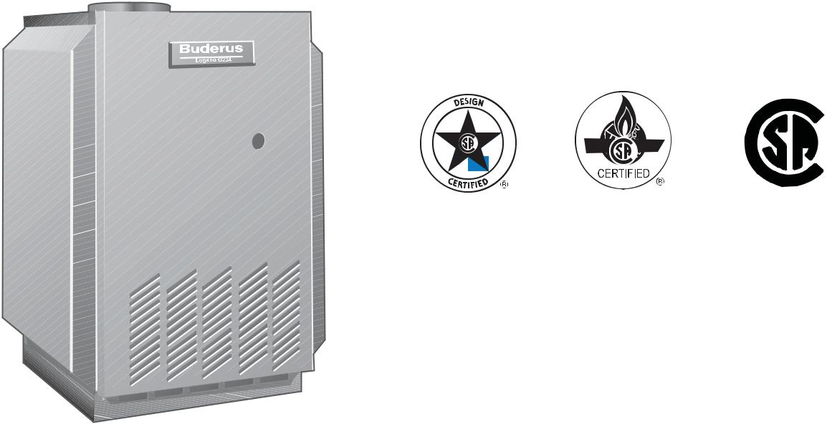

 ®

C US



**Engineering SpeciÞcations**

There shall be provided and installed a quantity of _____ Buderus G234X-55 fl oor standing hot water boiler(s), suitable with natural gas or propane. Boiler(s) shall have an AFUE effi ciency rating of 84.8%.

Boiler(s) shall utilize GL180M cast iron sectional heat exchanger.

Boiler(s) shall be constructed, tested and labeled in accordance with ASME Section IV and shall bear the ASME stamp. Boilers shall be CSA approved and have an applicable Canadian Registration number.

Heat exchanger shall be labeled for 58psig maximum working pressure rating.

Standard equipment shall include a 90° elbow, safety relief valve, drain valve, vent damper, pressure gauge, 30psig relief valve, and technical documentation.

Minimal clearances shall be integral to the boiler cabinet design; a removable door shall be used to access heat exchanger, burner components, gas valve and sensors.

Optional integrated 2107 series controller shall monitor and control all combustion process functions, control of the boiler water temperature to a value required by the connected components and shall display current water temperatures or fault conditions with changes in operation status. Additional control functions shall include an on/off button, rotary temperature knobs, LCD display for burner operation and button for fault condition reset. Outdoor reset may be accomplished with 2107 control using an outdoor air sensor.

|  |  |
| --- | --- |
|  | Bosch Thermotechnology Corporation |
| 1 of 5 | Londonderry, NH • Ft. Lauderdale, FL • Irvine, CA |

|  |  |  |
| --- | --- | --- |
| Bosch Thermotechnology Corp. reserves the right to make changes without notice due to | Tel: 1-800-283-3787 Fax: 1-603-965-7581 www.buderus.us |  |
| continuing engineering and technological advances | BTC 424008101 A | 04.2012 |  |  |
|  |  |  |

G234X-55



Conventional Gas Boiler



**Performance Data**

|  |  |  |
| --- | --- | --- |
|  | **Unit** | **Value** |
|  |  |  |
| Gas input | MBtu/h | 228 |
| Gross rated output | MBtu/h | 188 |
| IBR Rating | MBtu/h | 163 |
| Boiler horsepower | H.P | 6.05 |
| AFUE | % | 84.8 |
|  |  |  |



**General Data**

|  |  |  |
| --- | --- | --- |
|  | **Unit** | **Value** |
|  |  |  |
| Boiler category | – | Atmospheric |
| Heat exchanger construction | – | GL180M Cast Iron |
| Maximum allowable working pressure | PSIG | 58 |
| Water content | Gallons | 7.1 |
| Weight - shipping (approx.) | Lbs | 562 |
| Weight - operating (approx.) | Lbs | 621 |
| Standard relief valve size (inlet x outlet) | Inch | ¾ x ¾ |
| Standard relief valve pressure rating (other capacities available upon request) | PSI | 30 |
| Minimum capacity of safety relief valve | Lb / hr | 188 |
| Number of burner tubes | Qty | 4 |
| Venting category | – | I |
|  |  |  |



**Operational Data**

|  |  |  |
| --- | --- | --- |
|  | **Unit** | **Value** |
|  |  |  |
| Maximum supply water temperature | °F | 194 |
| Minimum return water temperature | °F | > 120° F |
|  |  |  |



**Electrical Data**

|  |  |  |
| --- | --- | --- |
|  | **Unit** | **Value** |
|  |  |  |
| Electrical voltage mains | VAC | 120 |
| Power consumption max load | Watts | 104 |
| Power consumption partial load | Watts | 29 |
| Max. permissible fuse rating | Amps | 15 |
|  |  |  |

|  |  |  |
| --- | --- | --- |
|  | Bosch Thermotechnology Corporation |  |
| 2 of 5 | Londonderry, NH • Ft. Lauderdale, FL • Irvine, CA |  |
|  |  |

|  |  |  |
| --- | --- | --- |
| Bosch Thermotechnology Corp. reserves the right to make changes without notice due to | Tel: 1-800-283-3787 Fax: 1-603-965-7581 www.buderus.us |  |
| continuing engineering and technological advances | BTC 424008101 A | 04.2012 |  |  |
|  |  |  |

G234X-55



Conventional Gas Boiler



**Burner Data**

|  |  |  |
| --- | --- | --- |
|  | **Unit** | **Value** |
|  |  |  |
| Allowable fuels | – | Natural gas, LP |
| Min Static Inlet Gas Pressure - NG | Inch W.C. | 7.0 |
| Max Static Inlet Gas Pressure - NG | Inch W.C. | 10.5 |
| Min Static Inlet Gas Pressure - LP | Inch W.C. | 11.0 |
| Max Static Inlet Gas Pressure - LP | Inch W.C. | 13.0 |
|  |  |  |



**Approval Data**

|  |  |
| --- | --- |
| **Approval description** | **Approval number** |
|  |  |
| Massachusetts Approval # | G3-0106-74 |
| New York MEA # | 217-98-E |
| CRN # | 7169.7C |
|  |  |

**Boiler Pressure Drop Curve (1 psi = 69 mbar, 1 GPM = 0.23 m³/h)**

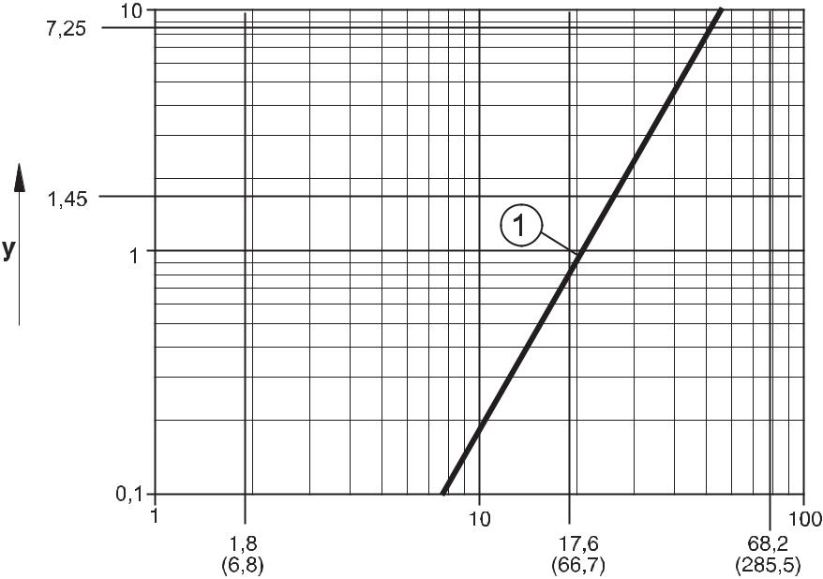

1. Flow Rate in GPM ( m³/h)
2. Pressure drops in psi

**1** 228 400 BTU/hr (boiler rating 55)

|  |  |
| --- | --- |
|  | Bosch Thermotechnology Corporation |
| 3 of 5 | Londonderry, NH • Ft. Lauderdale, FL • Irvine, CA |

|  |  |  |
| --- | --- | --- |
| Bosch Thermotechnology Corp. reserves the right to make changes without notice due to | Tel: 1-800-283-3787 Fax: 1-603-965-7581 www.buderus.us |  |
| continuing engineering and technological advances | BTC 424008101 A | 04.2012 |  |  |
|  |  |  |

G234X-55



Conventional Gas Boiler



**Boiler Dimensions and Connections**

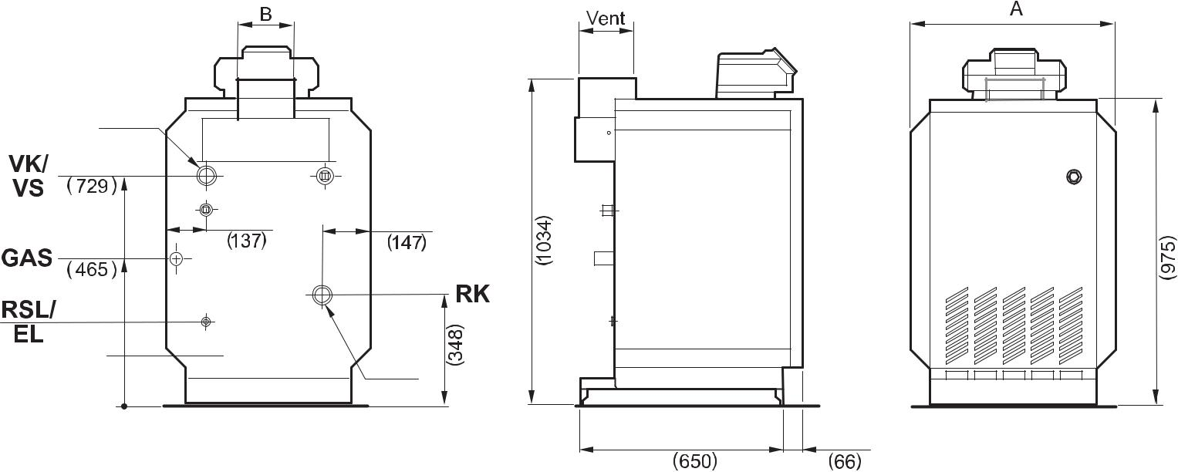

|  |  |  |  |  |
| --- | --- | --- | --- | --- |
| 1 ½" |  |  |  |  |
| 28 ¾ |  |  |  |  |
| 5 ⁷/₁₆ | 5 ¹⁵/₁₆ | |  |  |
| 18 ⅜ |  | 40¾ | ⁷ ₁₆38/ |  |
| ¾" |  |  |
| ¾" |  | ¾ |  |  |
|  | 1 ½" | 13 |  |  |
|  |  |  |  |
|  |  | 25 ⅝ | 2 ⅝ |  |
| **Tolerances are ± ¼" (6.35mm)** |  |  |  |  |



**Boiler Dimensions / Connections Data**

|  |  |  |  |
| --- | --- | --- | --- |
| **Item** | **Description** | **Unit** | **Value** |
|  |  |  |  |
| A | Boiler width | Inch | 29 ⅛ |
| VK/VS | Boiler supply / storage tank supply | Inch | 1½ FPT |
| GAS | Boiler gas connection + main isolating valve | Inch | 1 FPT |
| RK | Boiler return | Inch | 1½ FPT |
| RSL/EL | Return safety line / draining | Inch | ¾ |
| B | Vent | Inch | 7 |
|  |  |  |  |

|  |  |  |
| --- | --- | --- |
|  | Bosch Thermotechnology Corporation |  |
| 4 of 5 | Londonderry, NH • Ft. Lauderdale, FL • Irvine, CA |  |
|  |  |

Bosch Thermotechnology Corp. reserves the right to make changes without notice due to continuing engineering and technological advances | BTC 424008101 A | 04.2012

Tel: 1-800-283-3787 Fax: 1-603-965-7581 www.buderus.us

G234X-55



Conventional Gas Boiler

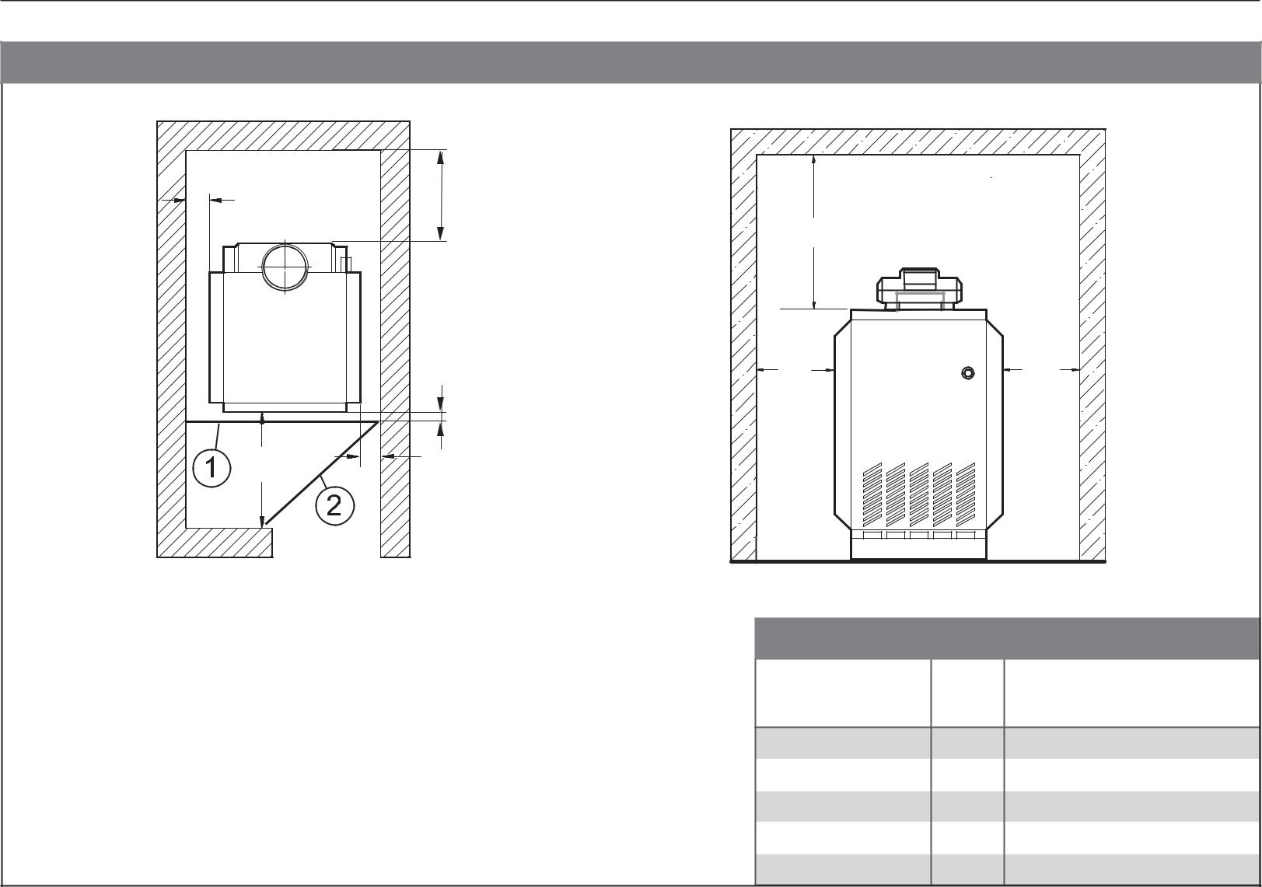

**Boiler Clearances**

W1

W4

|  |  |
| --- | --- |
|  | W1 |
| W3 | W2 |

1. Closed door
2. Open door

|  |  |  |
| --- | --- | --- |
| W5 |  |  |
| W1 |  | W2 |
| **Description** | **Unit** | **Minimum clearance** |

|  |  |  |
| --- | --- | --- |
| Wall clearance W1 | Inch | 2 |
| Wall clearance W2 | Inch | 2 |
| Wall clearance W3 | Inch | 33 |
| Wall clearance W4 | Inch | 6 |
| Top clearance W5 | Inch | 30 |

**DISCLAIMER**

Bosch Thermotechnology Corp. makes no warranty or representation, expressed or implied, with respect to the accuracy, completeness, or usefulness of this information, nor assumes any liability with respect to the use of any information contained within this document.

|  |  |  |
| --- | --- | --- |
|  | Bosch Thermotechnology Corporation |  |
| 5 of 5 | Londonderry, NH • Ft. Lauderdale, FL • Irvine, CA |  |
|  |  |

Bosch Thermotechnology Corp. reserves the right to make changes without notice due to continuing engineering and technological advances | BTC 424008101 A | 04.2012

Tel: 1-800-283-3787 Fax: 1-603-965-7581 www.buderus.us