**G334X- 73/92/116/132**

**Conventional Gas Boilers**

Engineering



Submittal

Sheet



**Boiler Overview**

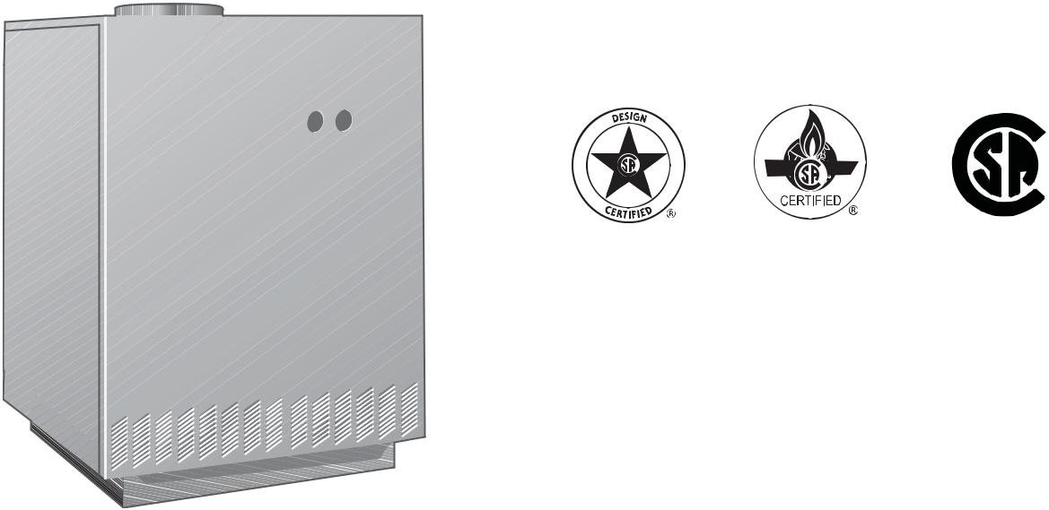

 ®

C US

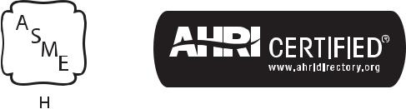

**Engineering SpeciÞcations**

There shall be provided and installed a quantity of _____ Buderus G334X-____ fl oor standing hot water boiler(s), suitable with natural gas or propane.

Boiler(s) shall have a thermal effi ciency rating of:

— G334X-73 = 81.2%

— G334X-92 = 81.6%

— G334X-116 = 81.7%

— G334X-132 = 81.7%

Boiler(s) shall utilize GL180M cast iron sectional heat exchanger.

Boiler(s) shall be constructed, tested and labeled in accordance with ASME Section IV and shall bear the ASME stamp. Boilers shall be CSA approved and have an applicable Canadian Registration number.

Heat exchanger shall be labeled for 58psig maximum working pressure rating.

Standard equipment shall include a 90° elbow, safety relief valve, drain valve, vent damper, pressure gauge, 30psig relief valve, and technical documentation.

Minimal clearances shall be integral to the boiler cabinet design; a removable door shall be used to access heat exchanger, burner components, gas valve and sensors.

|  |  |
| --- | --- |
|  | Bosch Thermotechnology Corp. |
| 1 of 5 | Londonderry, NH • Ft. Lauderdale, FL |

|  |  |  |
| --- | --- | --- |
| Bosch Thermotechnology Corp. reserves the right to make changes without notice due to | Tel: 1-866-642-3198 Fax: 1-603-965-7581 www.boschheatingandcooling.com |  |
| continuing engineering and technological advances | BTC 424108101 B | 04.2016 |  |  |
|  |  |  |

G334X- 73/92/116/132



Conventional Gas Boilers



**Performance Data**

|  |  |  |  |  |  |
| --- | --- | --- | --- | --- | --- |
|  | **Unit** | **G334X-73** | **G334X-92** | **G334X-116** | **G334X-132** |
|  |  |  |  |  |  |
| Gas input | MBtu/h | 301 | 378 | 476 | 541 |
| Gross rated output | MBtu/h | 249 | 314 | 396 | 450 |
| IBR Rating | MBtu/h | 217 | 273 | 344 | 392 |
| Boiler horsepower | H.P | 7.43 | 9.38 | 11.82 | 13.44 |
| Thermal effi ciency | % | 81.2 | 81.6 | 81.7 | 81.7 |
| Combustion effi ciency | % | 82.7 | 83.1 | 83.2 | 83.2 |
|  |  |  |  |  |  |

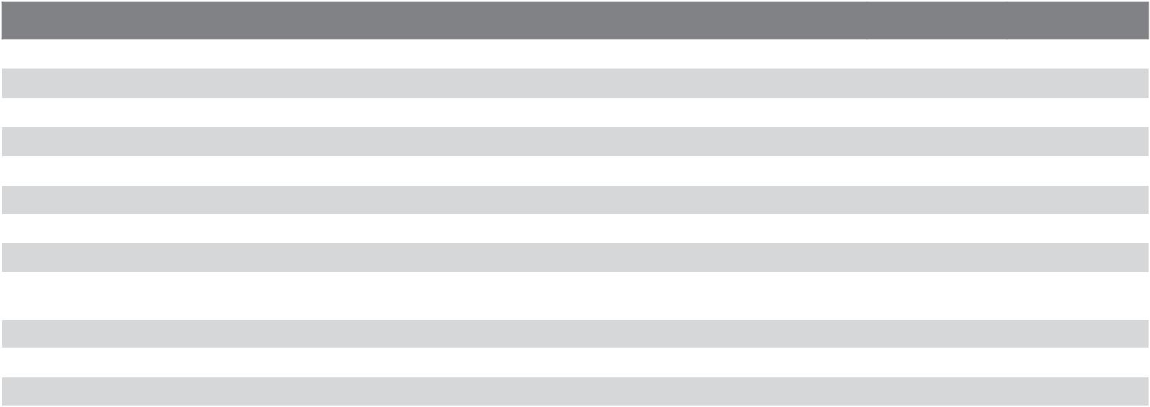

**General Data**

|  |  |  |  |  |  |  |  |  |  |  |
| --- | --- | --- | --- | --- | --- | --- | --- | --- | --- | --- |
|  | **Unit** | **G334X-73** | | **G334X-92** |  | **G334X-116** | |  | **G334X-132** |  |
|  |  |  |  |  | |  |  |  |  |  |
| Boiler category | – |  |  | Atmospheric | | | |  |  |  |
| Heat exchanger construction | – |  |  | GL180M Cast Iron | | | |  |  |  |
| Maximum allowable working pressure | PSIG |  |  |  | 58 | |  |  |  |  |
| Water content | Gallons | 9.2 |  |  |  | 13.5 |  |  | 15.6 |  |
|  | 11.4 |  |  |  |  |
| Weight - shipping (approx.) | Lbs | 758 |  | 930 |  | 1093 |  |  | 1265 |  |
| Weight - operating (approx.) | Lbs | 835 |  | 1021 |  | 1205 |  |  | 1395 |  |
| Standard relief valve size (inlet x outlet) | Inch |  |  |  | ¾ x ¾ | | |  |  |  |
| Standard relief valve pressure rating | PSI |  |  |  | 30 | |  |  |  |  |
| (other capacities available upon request) |  |  |  |  |  |  |  |
|  |  |  |  |  |  |  |  |  |  |
| Minimum capacity of safety relief valve | Lb / hr | 249 |  |  |  | 396 |  | 450 | |  |
|  | 314 |  |  |  |
| Number of burner tubes | Qty | 5 |  | 6 |  | 7 |  | 8 | |  |
| Venting category | – |  |  |  | I | | |  |  |  |
|  |  |  |  |  |  |  |  |  |  |  |

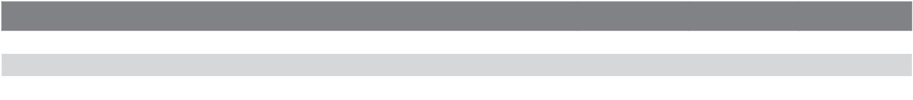

**Operational Data**

|  |  |  |  |  |  |  |
| --- | --- | --- | --- | --- | --- | --- |
|  | **Unit** | **G334X-73** | **G334X-92** |  | **G334X-116** | **G334X-132** |
|  |  |  |  |  |  |  |
| Maximum supply water temperature | °F |  |  | 194 | |  |
| Minimum return water temperature | °F |  |  | > 120° F | |  |
|  |  |  |  |  |  |  |

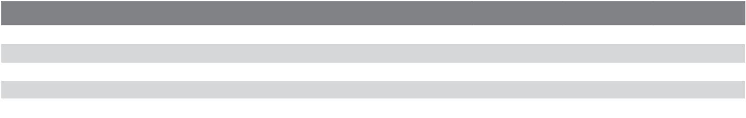

**Electrical Data**

|  |  |  |  |  |  |  |
| --- | --- | --- | --- | --- | --- | --- |
|  | **Unit** | **G334X-73** | **G334X-92** |  | **G334X-116** | **G334X-132** |
|  |  |  |  |  |  |  |
| Electrical voltage mains | VAC |  |  | 120 | |  |
| Power consumption max load | Watts |  |  | 30 | |  |
| Power consumption partial load | Watts |  |  | 20 | |  |
| Max. permissible fuse rating | Amps |  |  | 15 | |  |
|  |  |  |  |  |  |  |

Bosch Thermotechnology Corp.

Londonderry, NH • Ft. Lauderdale, FL

2 of 5

|  |  |  |
| --- | --- | --- |
| Bosch Thermotechnology Corp. reserves the right to make changes without notice due to | Tel: 1-866-642-3198 Fax: 1-603-965-7581 www.boschheatingandcooling.com |  |
| continuing engineering and technological advances | BTC 424108101 B | 04.2016 |  |  |
|  |  |  |

G334X- 73/92/116/132



Conventional Gas Boilers

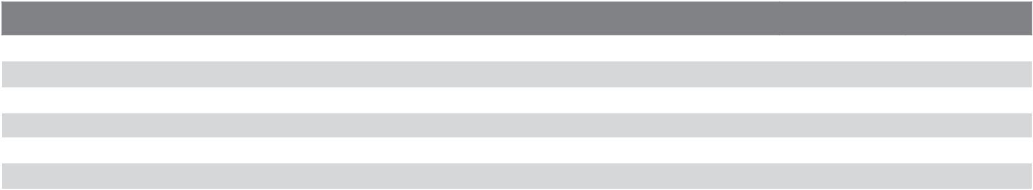

**Burner Data**

|  |  |  |  |  |  |  |
| --- | --- | --- | --- | --- | --- | --- |
|  | **Unit** | **G334X-73** | **G334X-92** |  | **G334X-116** | **G334X-132** |
|  |  |  |  | |  |  |
| Allowable fuels | – |  | Natural gas, LP | | |  |
| Min Static Inlet Gas Pressure - NG | Inch W.C. |  |  | 7.0 | |  |
| Max Static Inlet Gas Pressure - NG | Inch W.C. |  |  | 10.5 | |  |
| Min Static Inlet Gas Pressure - LP | Inch W.C. |  |  | 11.0 | |  |
| Max Static Inlet Gas Pressure - LP | Inch W.C. |  |  | 13.0 | |  |
|  |  |  |  |  |  |  |



**Approval Data**

|  |  |  |  |  |  |
| --- | --- | --- | --- | --- | --- |
| **Approval description** | **G334X-73** | **G334X-92** |  | **G334X-116** | **G334X-132** |
|  |  |  | |  |  |
| Massachusetts Approval # |  | G3-0106-184 | | |  |
| New York MEA # |  |  | 217-98-E | |  |
| CRN # |  |  | 7169.7C | |  |
|  |  |  |  |  |  |

**Boiler Pressure Drop Curve (1 psi = 69 mbar, 1 GPM = 0.23 m³/h)**

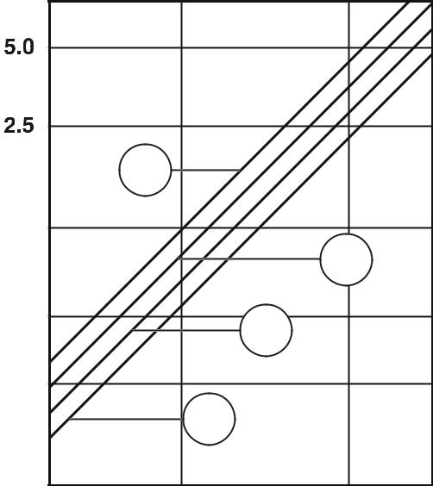

1

y



2

3



4



x

1. Flow Rate in GPM
2. Pressure drops in psi

[**1**] 301,200 BTU/hr (boiler rating 73) [**2**] 378,300 BTU/hr (boiler rating 92) [**3**] 476,000 BTU/hr (boiler rating 116) [**4**] 541,500 BTU/hr (boiler rating 132)

|  |  |
| --- | --- |
|  | Bosch Thermotechnology Corp. |
| 3 of 5 | Londonderry, NH • Ft. Lauderdale, FL |

|  |  |  |
| --- | --- | --- |
| Bosch Thermotechnology Corp. reserves the right to make changes without notice due to | Tel: 1-866-642-3198 Fax: 1-603-965-7581 www.boschheatingandcooling.com |  |
| continuing engineering and technological advances | BTC 424108101 B | 04.2016 |  |  |
|  |  |  |

G334X- 73/92/116/132



Conventional Gas Boilers



**Boiler Dimensions and Connections**

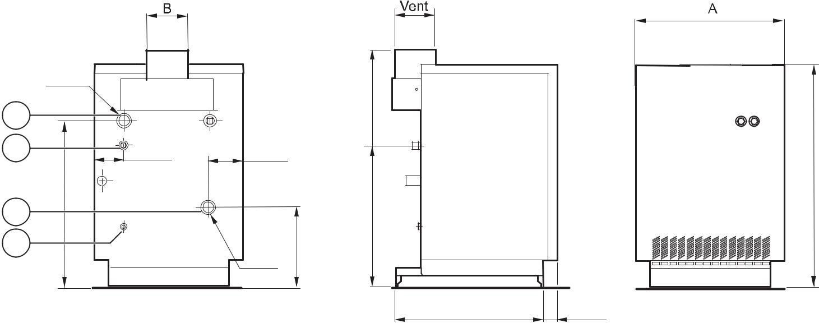

|  |  |  |  |  |  |  |
| --- | --- | --- | --- | --- | --- | --- |
|  | 1 ½ʺ |  |  |  |  |  |
| 1 |  |  |  | ⅛43 |  |  |
| 2 | 1 1⁄4 | 4 ⅝ |  |  |  |  |
| 4 | ⅝28 |  |  | ⅝ | ⅝40 |  |
| 3 | ¾ʺ |  | ⅝ | 23 |  |  |
|  | 1 ½ʺ | 13 |  |  |  |
|  |  |  |  |  |
|  |  |  |  |  |  |
|  |  |  |  | 25 ⅝ | 2 ⅝ |  |
| **Tolerances are ± ¼" (6.35mm)** | |  |  |  |  |  |

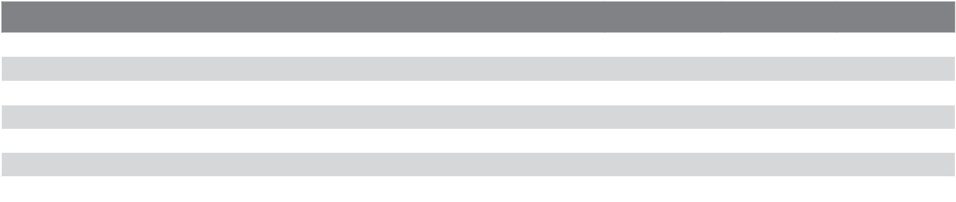

**Boiler Dimensions / Connections Data**

|  |  |  |  |  |  |  |  |  |  |  |
| --- | --- | --- | --- | --- | --- | --- | --- | --- | --- | --- |
| **Item** | **Description** | **Unit** | **G334X-73** | | **G334X-92** |  | **G334X-116** | | **G334X-132** |  |
|  |  |  |  |  |  |  |  |  |  |  |
| A | Boiler width | Inch | 34.5 |  | 41.7 |  | 48.8 |  | 56.9 |  |
| 1 | Boiler supply / storage tank supply | Inch |  |  |  | 1½ FPT | | |  |  |
| 2 | Boiler gas connection + main shutoff valve | Inch |  |  |  | 1¼ FPT | | |  |  |
| 3 | Return safety line / draining | Inch |  |  |  | ¾ | |  |  |  |
| 4 | Boiler return | Inch |  |  |  | 1½ FPT | | |  |  |
| B | Vent diameter | Inch | 8 |  |  |  | 10 |  | 10 |  |
|  | 9 |  |  |  |
|  |  |  |  |  |  |  |  |  |  |  |

|  |  |  |
| --- | --- | --- |
|  | Bosch Thermotechnology Corp. |  |
| 4 of 5 | Londonderry, NH • Ft. Lauderdale, FL |  |
|  |  |

|  |  |  |
| --- | --- | --- |
| Bosch Thermotechnology Corp. reserves the right to make changes without notice due to | Tel: 1-866-642-3198 Fax: 1-603-965-7581 www.boschheatingandcooling.com |  |
| continuing engineering and technological advances | BTC 424108101 B | 04.2016 |  |  |
|  |  |  |

G334X- 73/92/116/132



Conventional Gas Boilers

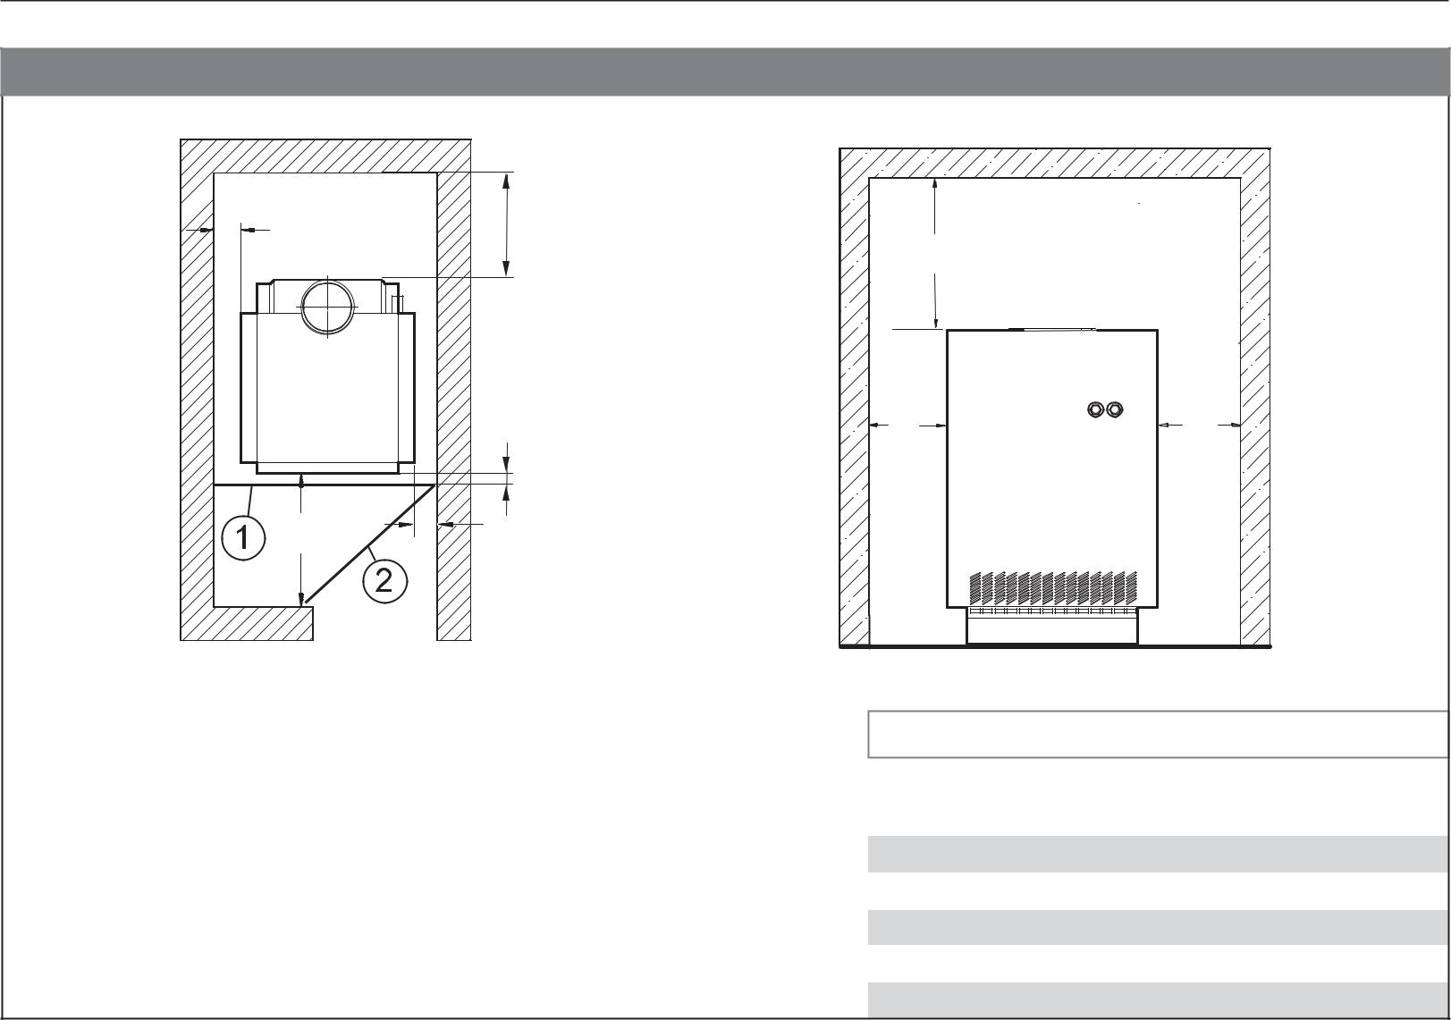

**Boiler Clearances**

W1

W4

|  |  |
| --- | --- |
|  | W1 |
| W3 | W2 |

|  |  |
| --- | --- |
| W5 |  |
| W1 | W2 |

1. Closed door
2. Open door

|  |  |  |  |
| --- | --- | --- | --- |
|  |  |  |  |
| **Description** | **Unit** | **Minimum Clearance** |  |
|  |  | **(All Models)** |  |
|  |  |  |  |
|  |  |  |  |
| Wall clearance W1 | Inch | 2 |  |
| Wall clearance W2 | Inch | 2 |  |
| Wall clearance W3 | Inch | 33 |  |
| Wall clearance W4 | Inch | 6 |  |
| Top clearance W5 | Inch | 30 |  |
|  |  |  |  |

**DISCLAIMER**

Bosch Thermotechnology Corp. makes no warranty or representation, expressed or implied, with respect to the accuracy, completeness, or usefulness of this information, nor assumes any liability with respect to the use of any information contained within this document.

|  |  |  |
| --- | --- | --- |
|  | Bosch Thermotechnology Corp. |  |
| 5 of 5 | Londonderry, NH • Ft. Lauderdale, FL |  |
|  |  |
|  |  |  |
| Bosch Thermotechnology Corp. reserves the right to make changes without notice due to | Tel: 1-866-642-3198 Fax: 1-603-965-7581 www.boschheatingandcooling.com |  |
| continuing engineering and technological advances | BTC 424108101 B | 04.2016 |  |
|  |  |