**G515/10**

**Cast Iron Boiler**

Engineering



Submittal



Sheet



**Boiler Overview**

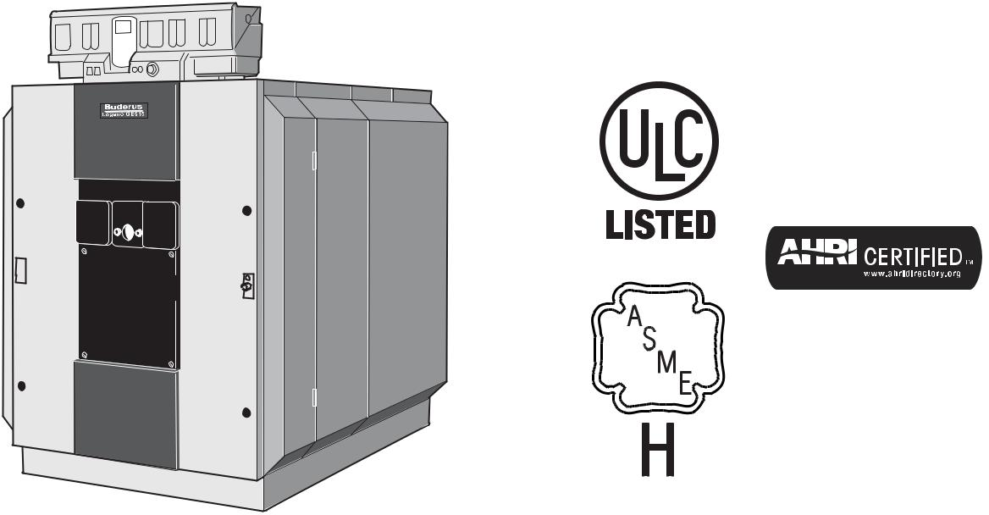

**Engineering Specifications**

There shall be provided and installed __ G515-10 Buderus sectional cast iron hot water boiler(s), suitable for forced draft firing with fuel oil #2, natural gas or propane.

Boiler(s) shall be fabricated with GL-180M high silicon cast iron. They shall be of pressurized wet base, double wall, sectional construction with precision machined steel push nipples. Boiler(s) shall have a central return stainless steel distribution pipe with two drilled openings per boiler section to allow proportionate water distribution over the entire length of the boiler.

Boiler(s) shall be constructed, tested and labeled in accordance with ASME Section IV and shall bear IBR ratings and the ASME stamp. Sections shall be labeled for 87psig maximum working pressure.

Boiler(s) shall be of full three pass design, suitable for forced draft firing and capable of achieving combustion efficiencies up to 88% for oil firing and 85% for gas firing. Gross stack temperatures at full firing rate shall not exceed 400°F.

The design of the boiler and the geometry of the combustion chamber shall eliminate the need for refractory material or a combustion target wall. Boiler flue collector shall be cast iron construction for long life.

Access to boiler firesides for inspection and maintenance shall be through a fully insulated and jacketed door, field-adjustable for left or right hinging. The seal between the door and the boiler casing shall be a permanent dry gasket for repeated positive sealing.

Boiler(s) shall be furnished with removable flue passage baffles to easily alter gross stack temperatures.

Boiler shall have no minimum return water temperature and no minimum flow requirement.

Boiler(s) shall not require any means of return water temperature control or minimum flow condition.

|  |  |
| --- | --- |
|  | Bosch Thermotechnology Corporation |
| 1 of 6 | Londonderry, NH • Ft. Lauderdale, FL |

|  |  |  |
| --- | --- | --- |
| Bosch Thermotechnology Corp. reserves the right to make changes without notice due | Tel: 1-800-283-3787 Fax: 1-603-965-7581 www.buderus.us |  |
| to continuing engineering and technological advances | BTC 412008104 C | 05.2013 |  |  |

G515/10



Cast Iron Boiler



**Performance Data**

|  |  |  |
| --- | --- | --- |
|  | **Unit** | **Value** |
| Boiler sections | Each | 10 |
| Oil input | GPH | 11.60 |
| Gas input | MBtu/h | 1660 |
| Rated gross output | MBtu/h | 1391 |
| IBR Rating | MBtu/h | 1210 |
| Boiler horsepower | H.P. | 41.6 |
| AHRI Natural gas combustion efficiency | % | 85.5 |
| AHRI Natural gas thermal efficiency | % | 83.9 |
| AHRI Oil combustion efficiency | % | 88.1 |
| AHRI Oil thermal efficiency | % | 86.4 |
|  |  |  |



**General Data**

|  |  |  |
| --- | --- | --- |
|  | **Unit** | **Value** |
|  |  |  |
| Boiler category | – | Non-Condensing |
| Heat exchanger construction | – | Cast Iron |
| Heating surface | Sq. Ft. | 168.50 |
| Maximum allowable working pressure | PSIG | 87 |
| Water content | Gallons | 96.70 |
| Weight - shipping (approx.) | Lbs | 3864 |
| Weight - operating (approx.) | Lbs | 4671 |
| Standard relief valve size (inlet x outlet) | Inch | 1 x 1¼ |
| Standard relief valve pressure rating (other capacities available upon request) | PSI | 50 |
| Minimum relief valve capacity | MBH | 1391 |
| Venting category (stack design will determine applicable category) | – | – |
|  |  |  |



**Operational Data**

|  |  |  |
| --- | --- | --- |
|  | **Unit** | **Value** |
|  |  |  |
| Fireside pressure drop | Inch W.C. | 0.85 - 1.17 |
| Required vent connection pressure | Inch W.C. | - 0.02 |
| Maximum allowable firebox pressure | Inch W.C. | 2.0 |
| Minimum flow rate | GPM | none |
| Maximum flow rate | GPM | none |
| Maximum supply water temperature | °F | 248 |
| Minimum return water temperature | °F | none |
|  |  |  |

|  |  |  |
| --- | --- | --- |
|  | Bosch Thermotechnology Corporation |  |
| 2 of 6 | Londonderry, NH • Ft. Lauderdale, FL |  |
|  |  |

|  |  |  |
| --- | --- | --- |
| Bosch Thermotechnology Corp. reserves the right to make changes without notice due | Tel: 1-800-283-3787 Fax: 1-603-965-7581 www.buderus.us |  |
| to continuing engineering and technological advances | BTC 412008104 C | 05.2013 |  |  |

G515/10



Cast Iron Boiler



**Burner Data**

|  |  |  |  |
| --- | --- | --- | --- |
|  | **Unit** | **Value** |  |
|  |  |  |  |
| Allowable fuels | – | Natural gas, LP, |  |
| Oil#2 |  |
|  |  |  |
| Motor voltages, gas/oil pressure and modes of operation will vary based upon final burner | – | – |  |
| selection - see burner specification sheet for additional details |  |
|  |  |  |
|  |  |  |  |



**Approval Data**

|  |  |
| --- | --- |
| **Approval description** | **Approval number** |
|  |  |
| Massachusetts Approval # | G3-0513-576 |
| New York MEA # | MEA 293-97-E |
| CRN # | 1530.9C |
|  |  |

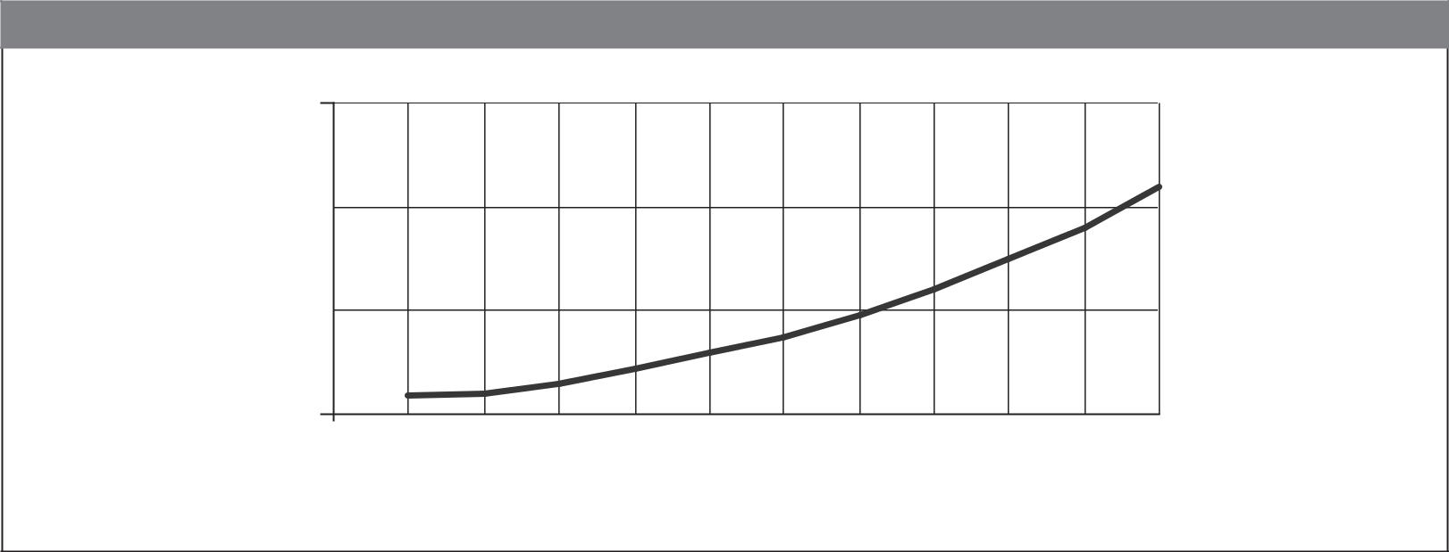

**Boiler Pressure Drop Curve**

|  |  |  |  |  |  |  |  |  |  |  |  |  |  |
| --- | --- | --- | --- | --- | --- | --- | --- | --- | --- | --- | --- | --- | --- |
|  | 3 |  |  |  |  |  |  |  |  |  |  |  |  |
| **of Head** | 2 |  |  |  |  |  |  |  |  |  |  |  |  |
| 1 |  |  |  |  |  |  |  |  |  |  |  |  |
| **Feet** |  |  |  |  |  |  |  |  |  |  |  |  |
|  |  |  |  |  |  |  |  |  |  |  |  |  |
|  | 0 |  |  |  |  |  |  |  |  |  |  |  |  |
|  | 20 | 30 | 40 | 50 | 60 | 70 | 80 | 90 | 100 | 110 | 120 | 130 |  |

**Flowrate (GPM)**

|  |  |
| --- | --- |
|  | Bosch Thermotechnology Corporation |
| 3 of 6 | Londonderry, NH • Ft. Lauderdale, FL |

|  |  |  |
| --- | --- | --- |
| Bosch Thermotechnology Corp. reserves the right to make changes without notice due | Tel: 1-800-283-3787 Fax: 1-603-965-7581 www.buderus.us |  |
| to continuing engineering and technological advances | BTC 412008104 C | 05.2013 |  |  |

G515/10



Cast Iron Boiler



**Boiler Dimensions and Connections**

|  |  |  |  |  |  |  |  |  |  |  |  |  |
| --- | --- | --- | --- | --- | --- | --- | --- | --- | --- | --- | --- | --- |
| 38 9/16" |  |  |  |  |  |  | 2 3/8" |  |  |  |  |  |
|  |  |  |  |  |  | (60 mm) |  |  |  |  |  |
| (980 mm) |  |  |  |  |  |  |  |  |  |  |  |
|  |  |  |  |  |  | 4 1/2" |  |  |  |  |  |
|  |  |  |  |  |  |  |  |  |  |  |  |
|  |  |  |  |  |  |  | (114 mm) |  |  |  |  |  |
|  | 3/16" | (1325 mm) | 61 1/4" | (1556 mm) | 51 3/4" | (1315 mm) | **VK** |  | (1120 mm) |  | **RK** |  |
|  | 4 1/2" |  |  |  |  |
|  | 52 | 44 1/8" |  |  |  |
|  | (115 mm) |  |  |  |
|  |  |  |  |  |
|  | 23 1/16"(586mm) |  | 23 1/16" | (585 mm) |  |
|  |  |  |  |  | 3 3/16" | |  |  |  | **EL** | |  |
| Ø | 10 5/8" |  |  |  | (80 mm) | |  |  |  |  |
|  |  |  |  |  |  |  | 10" |  |
| (270 mm) | |  |  |  |  |  |  |  |  |  |  |
|  |  |  |  |  |  |  |  |  | (250 mm) |  |
|  |  |  |  |  |  |  |  |  |  |  |  |
|  |  |  |  |  |  |  | **LK** |  |  |  |  |  |
|  |  |  |  |  |  |  | **L** |  |  |  |  |  |

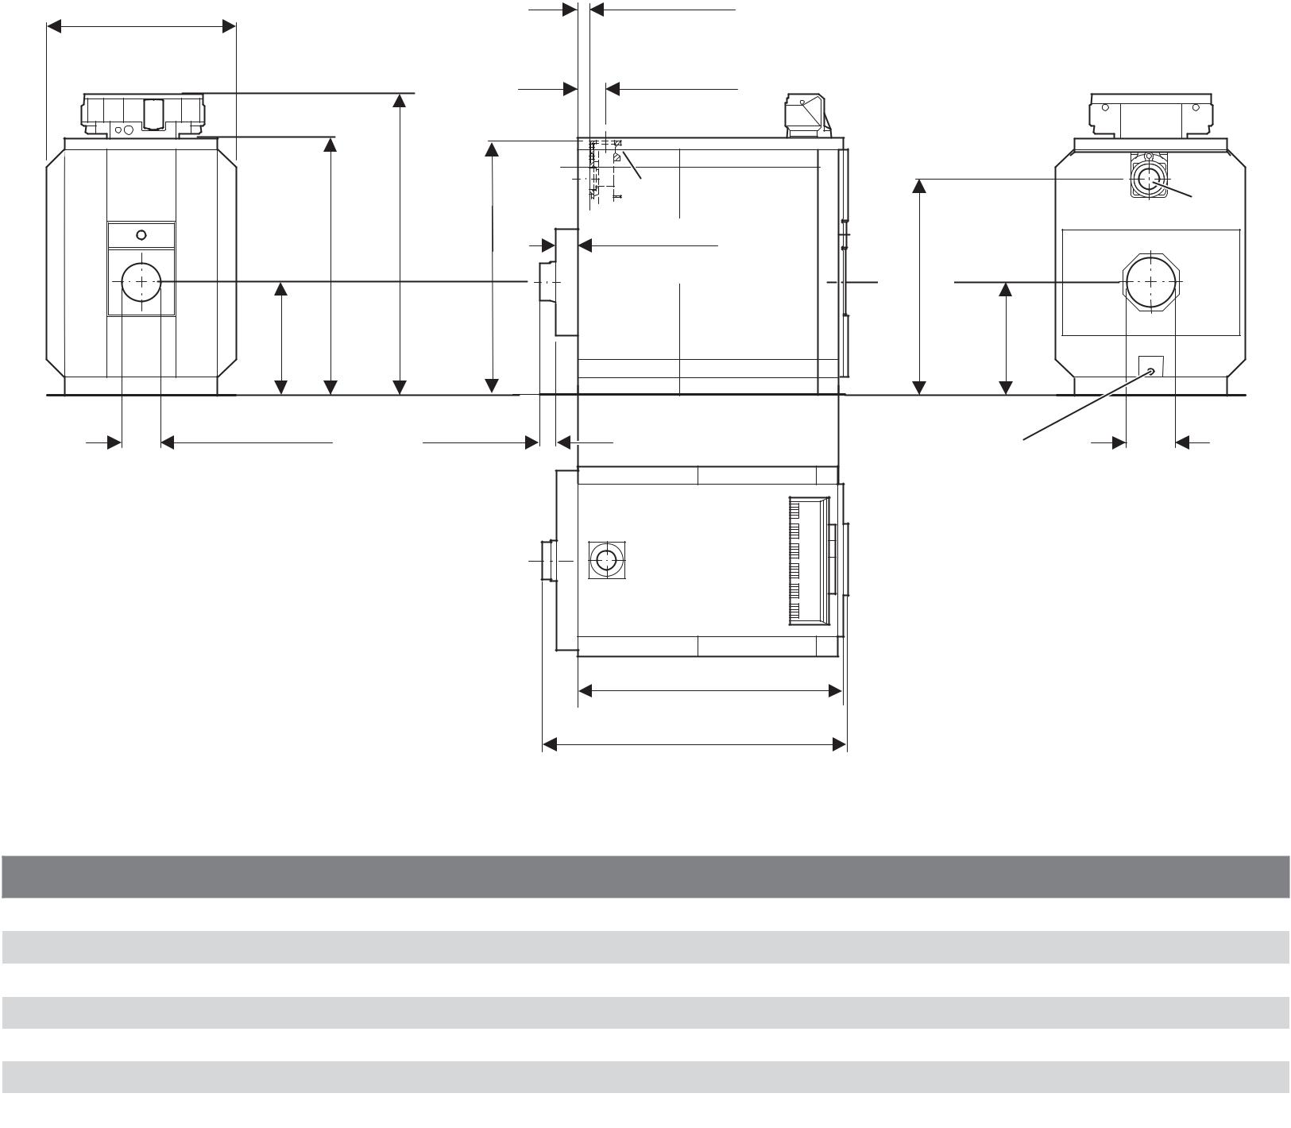

**Boiler Dimensions / Connections Data**

|  |  |  |  |
| --- | --- | --- | --- |
| **Item** | **Description** | **Unit** | **Value** |
| RK | Boiler return | Inch | 4 |
| VK | Boiler supply | Inch | 4 |
| EL | Boiler drain | Inch | ¾ |
| L | Boiler length including jacket | Inch | 82½ |
| LK | Boiler block length | Inch | 74¼ |
| − | Fire box depth | Inch | 66 |
|  |  |  |  |

* All dimensions above are within +/- ¼".

|  |  |  |
| --- | --- | --- |
|  | Bosch Thermotechnology Corporation |  |
| 4 of 6 | Londonderry, NH • Ft. Lauderdale, FL |  |
|  |  |

|  |  |  |
| --- | --- | --- |
| Bosch Thermotechnology Corp. reserves the right to make changes without notice due | Tel: 1-800-283-3787 Fax: 1-603-965-7581 www.buderus.us |  |
| to continuing engineering and technological advances | BTC 412008104 C | 05.2013 |  |  |

G515/10



Cast Iron Boiler



**Supply Manifold Connections**

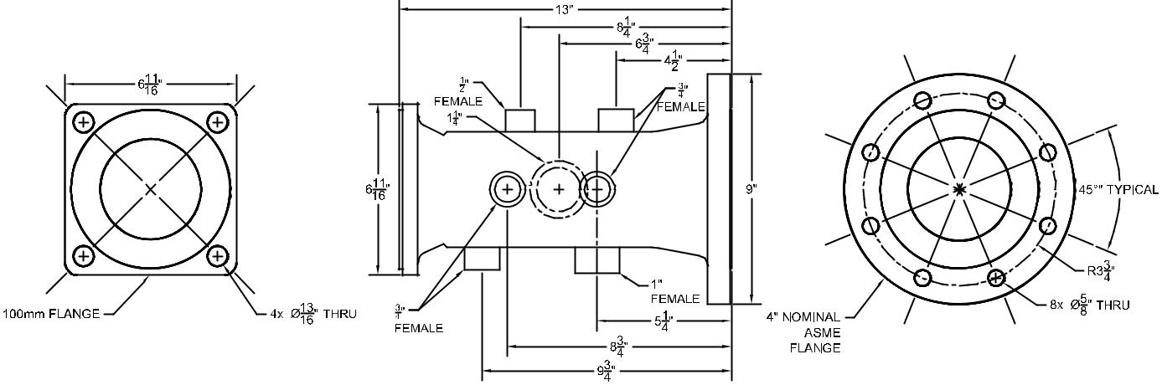

BOILER VIEW



**Return Manifold Connections**

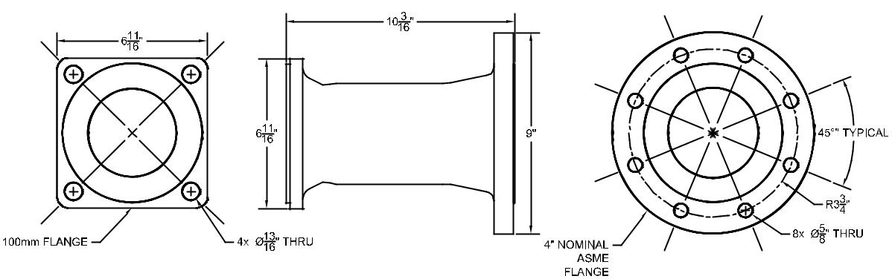

BOILER VIEW



|  |  |  |
| --- | --- | --- |
|  | Bosch Thermotechnology Corporation |  |
| 5 of 6 | Londonderry, NH • Ft. Lauderdale, FL |  |
|  |  |

|  |  |  |
| --- | --- | --- |
| Bosch Thermotechnology Corp. reserves the right to make changes without notice due | Tel: 1-800-283-3787 Fax: 1-603-965-7581 www.buderus.us |  |
| to continuing engineering and technological advances | BTC 412008104 C | 05.2013 |  |  |

G515/10



Cast Iron Boiler

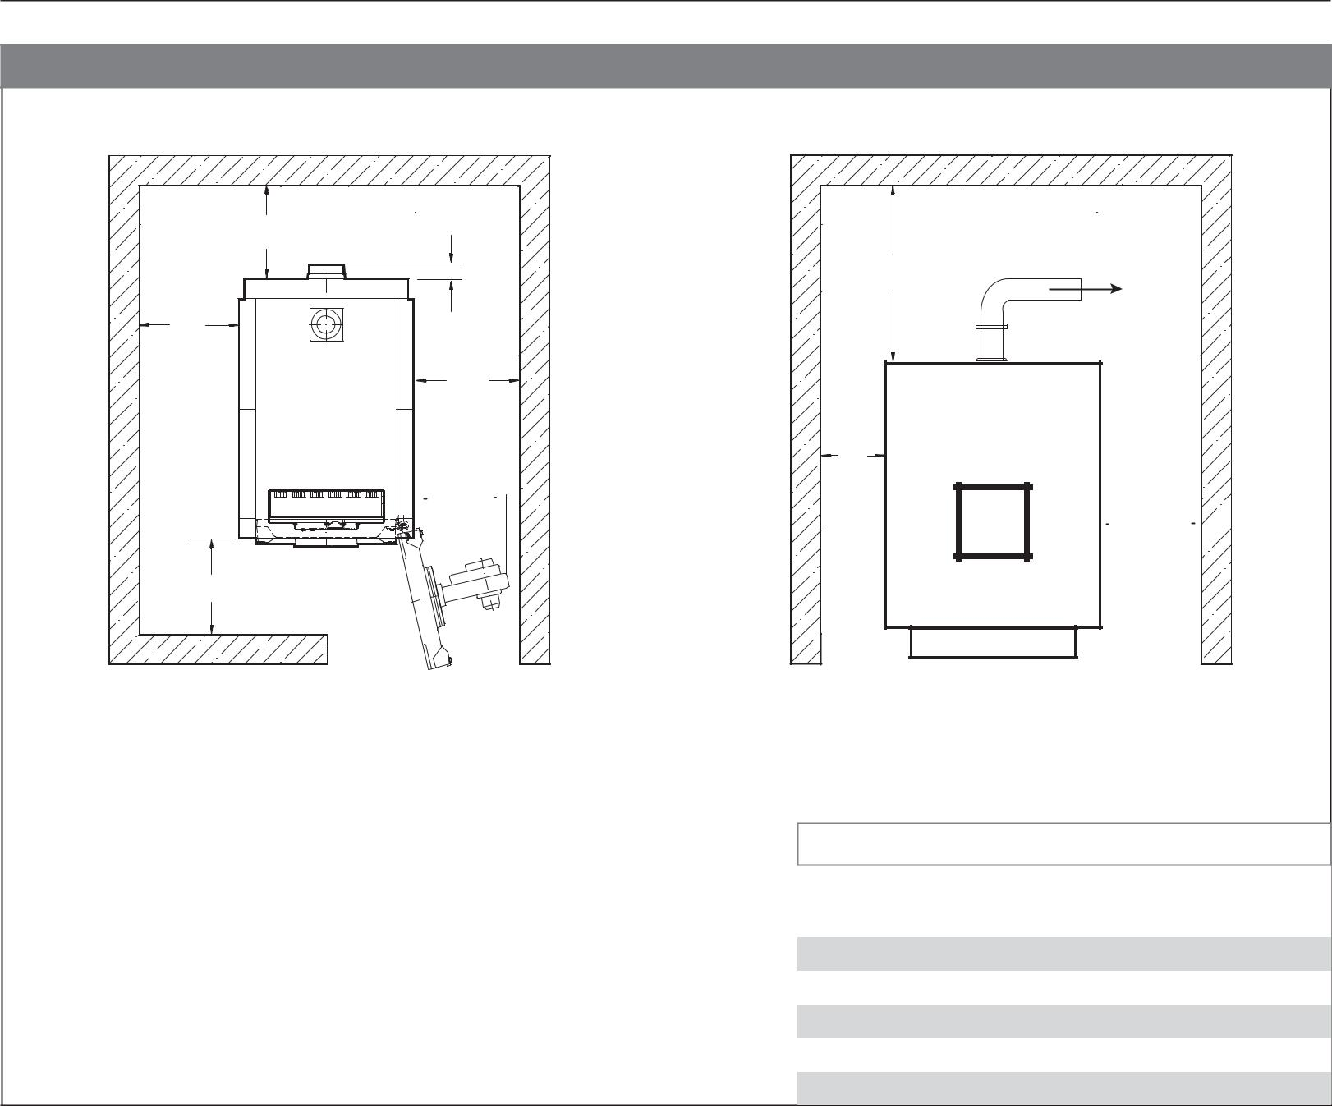

**Boiler Clearances**

|  |  |
| --- | --- |
| W4 |  |
| 7¾" | W5 |
| W1 | Supply header |
| W2 |  |
|  | W1 |

 A 

 W2 

W3

Top View Front View

*) Requires removal of burner for fully opening burner door.

**) Assembled boiler block only. May require use of segmented brush for cleaning.

|  |  |  |  |
| --- | --- | --- | --- |
|  |  |  |  |
| **Description** | **Unit** | **Recommended clearance** |  |
|  |  | **(minimum clearance)** |  |
|  |  |  |  |
|  |  |  |  |
| Wall clearance W1 | Inch | 32 (12) |  |
| Wall clearance W2 | Inch | burner length + 4 (12*) |  |
| Wall clearance W3 | Inch | burner length + 40 (48)** |  |
| Wall clearance W4 | Inch | ½ boiler length + 20 (36) |  |
| Top clearance W5 | Inch | 24 (24) |  |
|  |  |  |  |

**DISCLAIMER**

Bosch Thermotechnology Corp. makes no warranty or representation, expressed or implied, with respect to the accuracy, completeness, or usefulness of this information, nor assumes any liability with respect to the use of any information contained within this document.

|  |  |  |
| --- | --- | --- |
|  | Bosch Thermotechnology Corporation |  |
| 6 of 6 | Londonderry, NH • Ft. Lauderdale, FL |  |
|  |  |

|  |  |  |
| --- | --- | --- |
| Bosch Thermotechnology Corp. reserves the right to make changes without notice due | Tel: 1-800-283-3787 Fax: 1-603-965-7581 www.buderus.us |  |
| to continuing engineering and technological advances | BTC 412008104 C | 05.2013 |  |