**GB142-24**

**Condensing Gas Boiler**

Engineering



Submittal

Sheet



**Boiler Overview**

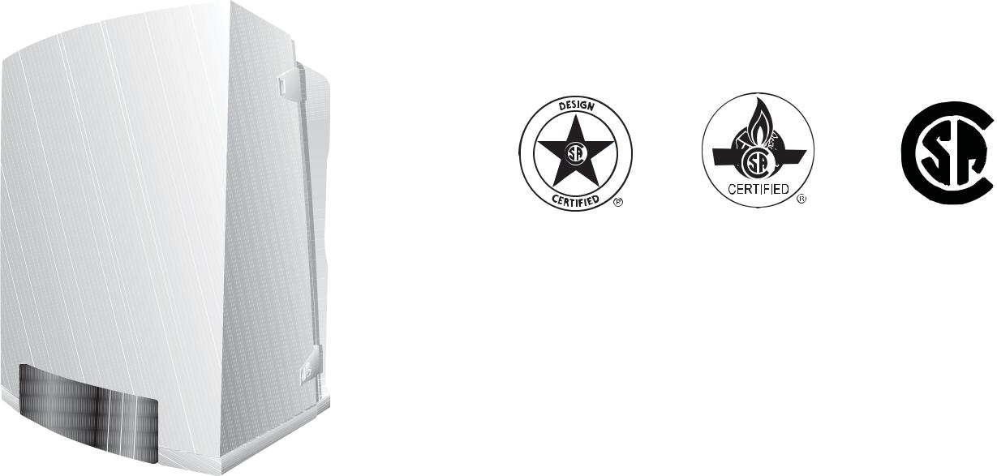

 ®

C US



**Engineering Specifications**

There shall be provided and installed a quantity of _____ Buderus GB142/24 wall-hung condensing hot water boiler(s), suitable for induced draft fi ring with natural gas or propane. Boiler(s) shall have an AFUE

effi ciency rating of 96.0%.

Boiler(s) shall utilize a cast aluminum heat exchanger with high quality condensing heating surfaces.

Boiler(s) shall be constructed, tested and labeled in accordance with ASME Section IV and shall bear the ASME stamp. Boilers shall be CSA approved and have an applicable Canadian Registration number.

Heat exchanger shall be labeled for 43.5psig maximum working pressure rating. An integrated pressure sensor shall ensure minimum and maximum water pressures are not exceeded.

Boiler shall be capable of modulating fi ring from 100% to 30% of capacity continuously based upon (i) supply and return water temperatures, and/or (ii) outdoor reset computerized control. Gross stack temperatures at full

fi ring rate shall not exceed 180°F.

Standard equipment shall include a pump group assembly; Grundfos UPS15-58 three-speed circulator, supply and return shut-off valves, pressure gauge, 30psig relief valve and hydraulic separator with NPT system connections.

Minimal clearances shall be integral to the boiler cabinet design; a removable housing shall be used to access heat exchanger, burner components, gas valve and sensors.

Integrated controller shall monitor and control all combustion process functions, control of the boiler water temperature to a value required by the connected components and shall display current water temperatures or fault conditions with changes in operation status. Additional control functions shall include an on/off button, rotary temperature knobs, LED for burner operation and button for fault condition reset.

Independent outdoor temperature reset may be accomplished with the optional AM10 controller; a mounting enclosure shall be included with the provided resistance dependent sensor. Standard communication interface from the AM10 to boiler shall be a two-wire low voltage bus.

|  |  |
| --- | --- |
|  | Bosch Thermotechnology Corporation |
| 1 of 6 | Londonderry, NH • Ft. Lauderdale, FL • Irvine, CA |

|  |  |  |
| --- | --- | --- |
| Bosch Thermotechnology Corp. reserves the right to make changes without notice due to | Tel: 1-800-283-3787 Fax: 1-603-965-7581 www.buderus.us |  |
| continuing engineering and technological advances | BTC 435008101 A | 05.2012 |  |  |
|  |  |  |

GB142-24



Condensing Gas Boiler



**Performance Data**

|  |  |  |
| --- | --- | --- |
|  | **Unit** | **Value** |
|  |  |  |
| Gas input | MBtu/h | 84.8 |
| Gross rated output | MBtu/h | 75.2 |
| IBR Rating | MBtu/h | 65 |
| Boiler horsepower | H.P | 2.2 |
| AFUE thermal effi ciency | % | 96 |
|  |  |  |



**General Data**

|  |  |  |
| --- | --- | --- |
|  | **Unit** | **Value** |
|  |  |  |
| Boiler category | – | Condensing |
| Heat exchanger construction | – | Aluminum |
| Maximum allowable working pressure | PSIG | 43.5 |
| Water content | Gallons | 0.7 |
| Weight - shipping (approx.) | Lbs | 110 |
| Weight - operating (approx.) | Lbs | 136 |
| Standard relief valve size (inlet x outlet) | Inch | ¾ x ¾ |
| Standard relief valve pressure rating (other capacities available upon request) | PSI | 30 |
| Venting category | – | IV |
|  |  |  |



**Operational Data**

|  |  |  |
| --- | --- | --- |
|  | **Unit** | **Value** |
|  |  |  |
| Circulator setting | Speed | Low |
| Maximum fl ow rate | GPM | 11 |
| Minimum fl ow rate | GPM | 4 |
| Maximum supply water temperature | °F | 194 |
|  |  |  |



**Electrical Data**

|  |  |  |
| --- | --- | --- |
|  | **Unit** | **Value** |
|  |  |  |
| Electrical voltage mains | V AC | 120 |
| Electrical voltage controls | V AC | 120 |
| Power consumption max load | Watts | 96 |
| Power consumption partial load | Watts | 22 |
| Max. permissible fuse rating | Amps | 15 |
|  |  |  |

2 of 6

Bosch Thermotechnology Corporation Londonderry, NH • Ft. Lauderdale, FL • Irvine, CA

|  |  |  |
| --- | --- | --- |
| Bosch Thermotechnology Corp. reserves the right to make changes without notice due to | Tel: 1-800-283-3787 Fax: 1-603-965-7581 www.buderus.us |  |
| continuing engineering and technological advances | BTC 435008101 A | 05.2012 |  |  |
|  |  |  |

GB142-24



Condensing Gas Boiler



**Burner Data**

|  |  |  |
| --- | --- | --- |
|  | **Unit** | **Value** |
|  |  |  |
| Allowable fuels | – | Natural gas, LP |
| Min Inlet Gas Pressure - NG | Inch W.C. | 3.5 |
| Max Inlet Gas Pressure - NG | Inch W.C. | 10.5 |
| Min Inlet Gas Pressure - LP | Inch W.C. | 8.0 |
| Max Inlet Gas Pressure - LP | Inch W.C. | 13.0 |
|  |  |  |



**Approval Data**

|  |  |
| --- | --- |
| **Approval description** | **Approval number** |
|  |  |
| Massachusetts Approval # | G3-0610-523 |
| New York MEA # | MEA 419-07-E |
| CRN # | 7790.7C |
|  |  |

**Boiler Pressure Drop Curve**

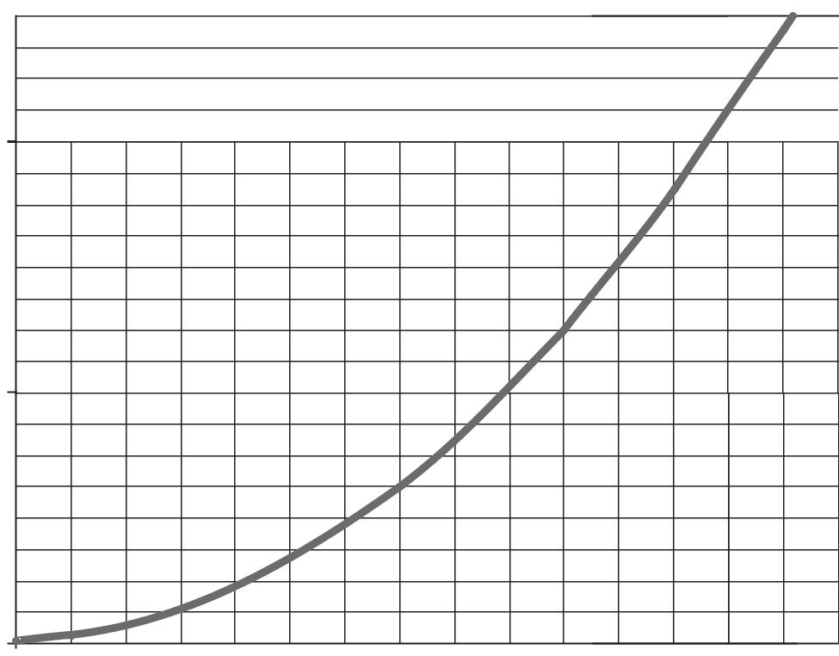

|  |  |  |  |  |  |  |  |  |  |  |  |  |  |  |  |  |  |
| --- | --- | --- | --- | --- | --- | --- | --- | --- | --- | --- | --- | --- | --- | --- | --- | --- | --- |
|  | 20 |  |  |  |  |  |  |  |  |  |  |  |  |  |  |  |  |
|  | 19 |  |  |  |  |  |  |  |  |  |  |  |  |  |  |  |  |
|  | 18 |  |  |  |  |  |  |  |  |  |  |  |  |  |  |  |  |
|  | 17 |  |  |  |  |  |  |  |  |  |  |  |  |  |  |  |  |
|  | 16 |  |  |  |  |  |  |  |  |  |  |  |  |  |  |  |  |
|  | 15 |  |  |  |  |  |  |  |  |  |  |  |  |  |  |  |  |
|  | 14 |  |  |  |  |  |  |  |  |  |  |  |  |  |  |  |  |
|  | 13 |  |  |  |  |  |  |  |  |  |  |  |  |  |  |  |  |
| **of Head** | 12 |  |  |  |  |  |  |  |  |  |  |  |  |  |  |  |  |
| 11 |  |  |  |  |  |  |  |  |  |  |  |  |  |  |  |  |
| 10 |  |  |  |  |  |  |  |  |  |  |  |  |  |  |  |  |
| **Feet** | 9 |  |  |  |  |  |  |  |  |  |  |  |  |  |  |  |  |
| 8 |  |  |  |  |  |  |  |  |  |  |  |  |  |  |  |  |
|  |  |  |  |  |  |  |  |  |  |  |  |  |  |  |  |  |
|  | 7 |  |  |  |  |  |  |  |  |  |  |  |  |  |  |  |  |
|  | 6 |  |  |  |  |  |  |  |  |  |  |  |  |  |  |  |  |
|  | 5 |  |  |  |  |  |  |  |  |  |  |  |  |  |  |  |  |
|  | 4 |  |  |  |  |  |  |  |  |  |  |  |  |  |  |  |  |
|  | 3 |  |  |  |  |  |  |  |  |  |  |  |  |  |  |  |  |
|  | 2 |  |  |  |  |  |  |  |  |  |  |  |  |  |  |  |  |
|  | 1 |  |  |  |  |  |  |  |  |  |  |  |  |  |  |  |  |
|  | 0 |  |  |  |  |  |  |  |  |  |  |  |  |  |  |  |  |
|  | 0 | 1 | 2 | 3 | 4 | 5 | 6 | 7 | 8 | 9 | 10 | 11 | 12 | 13 | 14 | 15 |  |

**Flowrate (GPM)**

|  |  |  |  |
| --- | --- | --- | --- |
|  |  | Bosch Thermotechnology Corporation |  |
| 3 of 6 |  | Londonderry, NH • Ft. Lauderdale, FL • Irvine, CA |  |
|  | |  |  |
| Bosch Thermotechnology Corp. reserves the right to make changes without notice due to | | Tel: 1-800-283-3787 Fax: 1-603-965-7581 www.buderus.us |  |
| continuing engineering and technological advances | | BTC 435008101 A | 05.2012 |  |  |
|  |  |  |  |

GB142-24



Condensing Gas Boiler



**Boiler Dimensions and Connections**

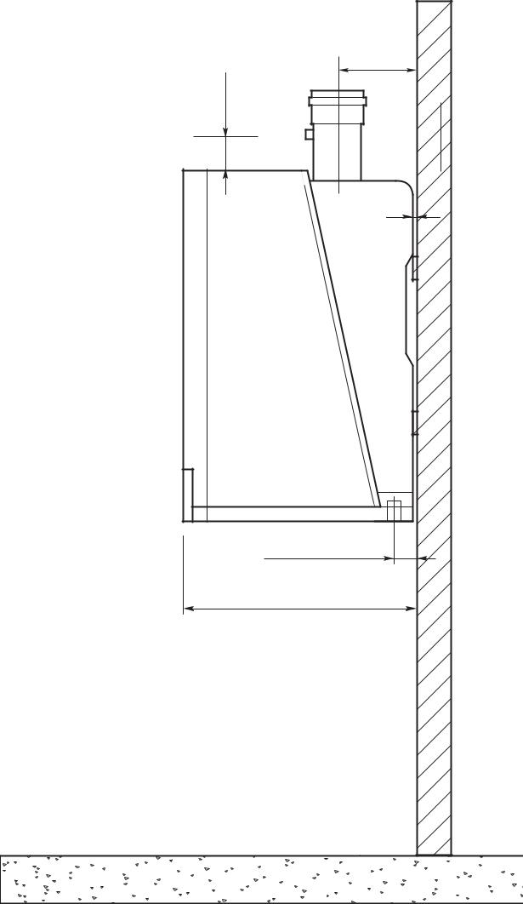

|  |  |  |
| --- | --- | --- |
| mm) | 6.2" |  |
| (158 mm) |  |
| 4" (100 |  |  |
|  | 0.25" |  |
|  | (6 mm) |  |
|  | 1.8" (46 mm) |  |
|  | 18.7" (475 mm) |  |

|  |  |  |  |  |  |  |
| --- | --- | --- | --- | --- | --- | --- |
|  |  |  | 22" (560 mm) | | |  |
|  |  | 13.2" (335 mm) | | 4.3" (110 mm) | |  |
| 5.5" (239 mm) | |  | **A** |  | **B** |  |
|  | mm) | 3" (75 mm) | |  |  |  |
|  |  |  |  |  |  |
|  | (190 |  | **C** |  |  |  |
|  |  |  |  |  |  |
| mm) | 7.5" |  | 16" (420 mm) | | |  |
|  |  |  |  |  |
| 28" (712 | mm) |  |  |  |  |  |
|  | 1.2" (30 | **D** | **E** |  | **F G** |  |
|  |  | 2.2" (55 mm)3"(75mm) | 6" (150 mm) | 6" (150 mm) | 3" (75 mm) |  |

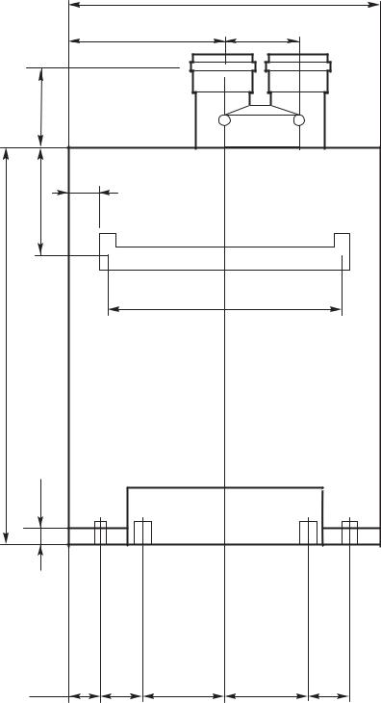

**Boiler Dimensions / Connections Data**

|  |  |  |  |
| --- | --- | --- | --- |
| **Item** | **Description** | **Unit** | **Value** |
| A | Flue gas connection (inside diameter) | Inch | 3 |
| B | Air intake (inside diameter) | Inch | 3 |
| C | Wall bracket | − | − |
| D | Boiler gas connection | Inch | ¾ |
| E | Boiler condensate drain (inside diameter) | Inch | 1.3 |
| F | Boiler supply | Inch | 1 |
| G | Boiler return | Inch | 1 |
|  |  |  |  |

|  |  |  |
| --- | --- | --- |
|  | Bosch Thermotechnology Corporation |  |
| 4 of 6 | Londonderry, NH • Ft. Lauderdale, FL • Irvine, CA |  |
|  |  |

|  |  |  |
| --- | --- | --- |
| Bosch Thermotechnology Corp. reserves the right to make changes without notice due to | Tel: 1-800-283-3787 Fax: 1-603-965-7581 www.buderus.us |  |
| continuing engineering and technological advances | BTC 435008101 A | 05.2012 |  |  |
|  |  |  |

GB142-24



Condensing Gas Boiler

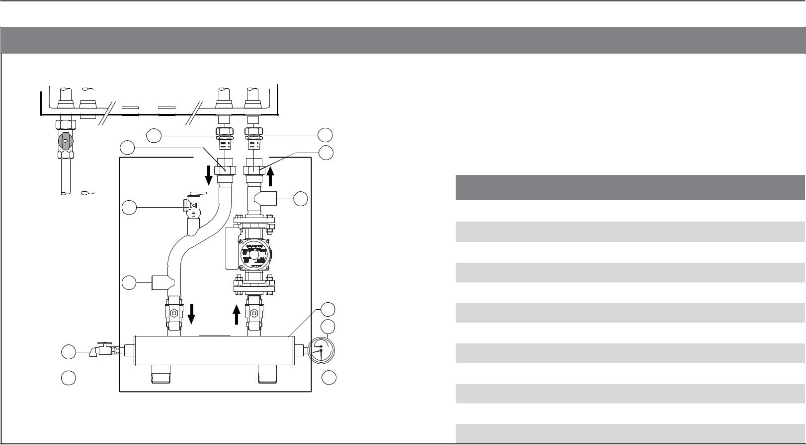

**Pump Manifold Connections**

GB142

|  |  |  |
| --- | --- | --- |
| 1 | 2 |  |
| 11 | 11 |  |
|  |  |
| 3 | 4 |  |
|  |  |

5

6

10

8

9  7

|  |  |  |  |
| --- | --- | --- | --- |
|  |  |  |  |
|  |  |  |  |
| **Ref** | **Description** | **Unit** | **Value** |
|  |  |  |  |
| 1 | Compression fi tting (heating supply) | − | − |
| 2 | Compression fi tting (heating return) | − | − |
| 3 | Relief valve | − | − |
| 4 | DHW return | Inch | 1 FPT |
| 5 | DHW supply | Inch | 1 FPT |
| 6 | Low loss header | − | − |
| 7 | System return | Inch | 1½ MPT |
| 8 | Drain valve | − | − |
| 9 | System supply | Inch | 1½ MPT |
| 10 | Tridicator | − | − |
| 11 | Di electric union | − | − |
|  |  |  |  |

**Grundfos UPS 15-58 FC Pressure Drop Curve**

|  |  |  |  |
| --- | --- | --- | --- |
| H |  |  |  |
| [ft] |  |  |  |
| 20 |  |  |  |
| 3 |  |  |  |
| 18 |  | With check valve |  |
| 2 |  |  |
| 16 | 3 | Circulator speed - high |  |
|  |  |
| 14 | 2 | Circulator speed - medium |  |
| 1 |  |
|  |  |  |
| 12 | 1 | Circulator speed - low |  |
|  |  |
| 10 |  |  |  |

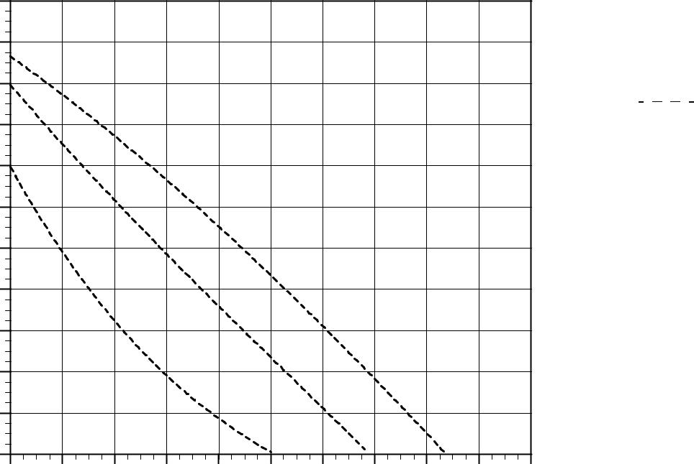

8

6

4

2

0

0 2 4 6 8 10 12 14 16 18 20

Q [GPM]

5 of 6

Bosch Thermotechnology Corporation Londonderry, NH • Ft. Lauderdale, FL • Irvine, CA

|  |  |  |
| --- | --- | --- |
| Bosch Thermotechnology Corp. reserves the right to make changes without notice due to | Tel: 1-800-283-3787 Fax: 1-603-965-7581 www.buderus.us |  |
| continuing engineering and technological advances | BTC 435008101 A | 05.2012 |  |  |
|  |  |  |

GB142-24



Condensing Gas Boiler

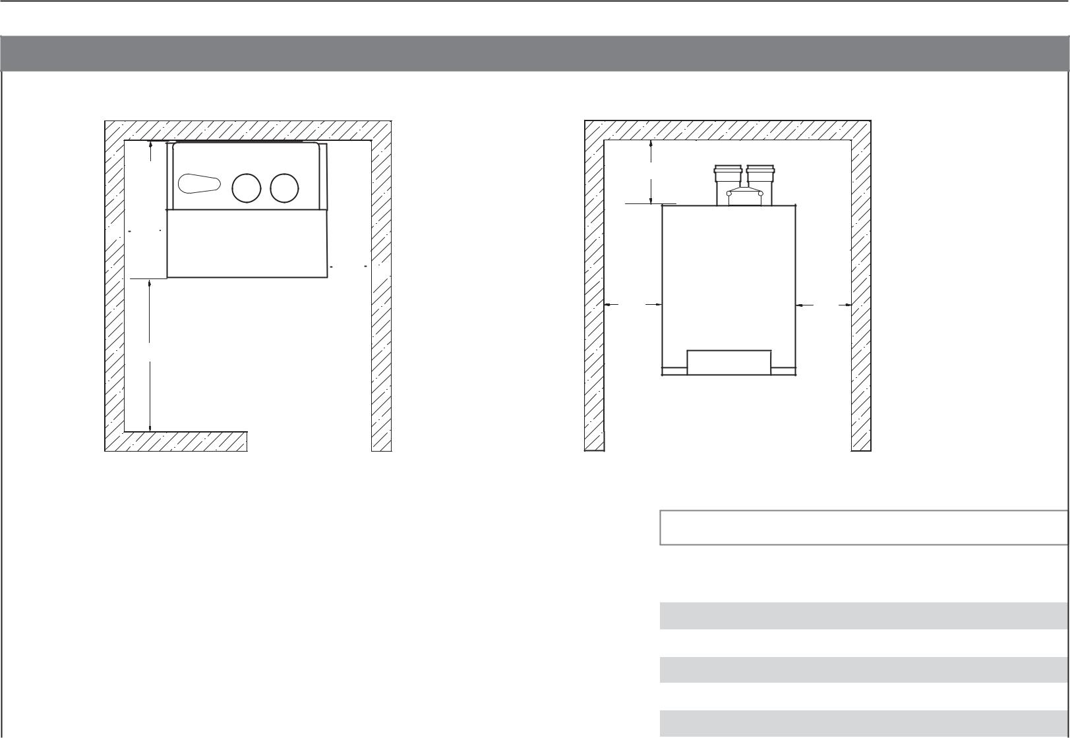

**Boiler Clearances**

|  |  |
| --- | --- |
| W4 | W5 |

 W1

 W2 

|  |  |
| --- | --- |
| W1 | W2 |

W3

Top View Front View

|  |  |  |  |
| --- | --- | --- | --- |
|  |  |  |  |
|  | **Description** | **Unit** | **Minimum clearance** |
|  |  |  |  |
|  | Wall clearance W1 | Inch (mm) | > 6 (150) |
|  | Wall clearance W2 | Inch (mm) | > 4 (100) |
|  | Wall clearance W3 | Inch (mm) | 20 (500) |
|  | Wall clearance W4 | Inch (mm) | Wall Mounted |
|  | Top clearance W5 | Inch (mm) | > 8 (203) |
|  |  |  |  |

**DISCLAIMER**

Bosch Thermotechnology Corp. makes no warranty or representation, expressed or implied, with respect to the accuracy, completeness, or usefulness of this information, nor assumes any liability with respect to the use of any information contained within this document.

|  |  |  |
| --- | --- | --- |
|  | Bosch Thermotechnology Corporation |  |
| 6 of 6 | Londonderry, NH • Ft. Lauderdale, FL • Irvine, CA |  |
|  |  |

|  |  |  |
| --- | --- | --- |
| Bosch Thermotechnology Corp. reserves the right to make changes without notice due to | Tel: 1-800-283-3787 Fax: 1-603-965-7581 www.buderus.us |  |
| continuing engineering and technological advances | BTC 435008101 A | 05.2012 |  |
|  |  |