**GB162-80**

**Condensing Gas Boiler**

Engineering



Submittal

Sheet



**Boiler Overview**

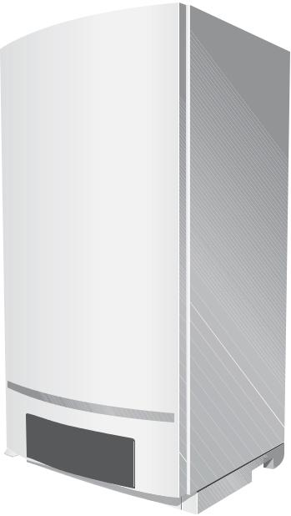

 ®

C US



**Engineering Specifications**

There shall be provided and installed a quantity of _____ Buderus GB162/80 wall-hung condensing hot water boiler(s), suitable for induced draft fi ring with natural gas or propane. Boiler(s) shall have an AFUE

effi ciency rating of 93.8%.

Boiler(s) shall utilize ALUplus heat exchanger with high quality condensing heating surface with plasma polymerization for a longer service life and lower maintenance.

Boiler(s) shall be constructed, tested and labeled in accordance with ASME Section IV and shall bear the ASME stamp. Boilers shall be CSA approved and have an applicable Canadian Registration number.

Heat exchanger shall be labeled for 58psig (4Bar) maximum working pressure rating. An integrated pressure sensor shall ensure minimum and maximum water pressures are not exceeded.

Boiler shall be capable of modulating fi ring from 100% to 25% of capacity continuously based upon (i) supply and return water temperatures, and/or (ii) outdoor reset computerized control. Gross stack temperatures at full

fi ring rate shall not exceed 180°F (82°C).

Standard equipment shall include a pump group assembly; Grundfos UP26-99 circulator, integral fl ow check, supply and return shut-off valves, pressure gauge, 30psig (2.6Bar) pressure relief valve and gas supply shut-off valve.

Minimal clearances shall be integral to the boiler cabinet design; a hinged door with locking feature shall be used to access heat exchanger, burner components, gas valve and sensors.

Integrated controller shall monitor and control all combustion process functions, control of the boiler water temperature to a value required by the connected components and shall display current water temperatures or fault conditions with changes in operation status. Additional control functions shall include an on/off button, rotary temperature knobs, LED for burner operation and button for fault condition reset.

Independent outdoor temperature reset may be accomplished with the optional AM10 controller; a mounting enclosure shall be included with the provided resistance dependent sensor.

|  |  |
| --- | --- |
|  | Bosch Thermotechnology Corp. |
| 1 of 6 | Londonderry, NH • Ft. Lauderdale, FL |

|  |  |  |
| --- | --- | --- |
| Bosch Thermotechnology Corp. reserves the right to make changes without notice due to | Tel: 1-800-283-3787 Fax: 1-603-965-7581 www.buderus.us |  |
| continuing engineering and technological advances | BTC 432008101 D | 12.2013 |  |  |
|  |  |  |

GB162-80



Condensing Gas Boiler



**Performance Data**

|  |  |  |  |
| --- | --- | --- | --- |
|  | **Unit** | **Natural Gas** | **LP Gas** |
| Gas input | MBH (kW) | 290 (85) | 270 (79) |
| Gross rated output | MBH (kW) | 260 (76.5) | 242 (71) |
| Net IBR Rating | MBH (kW) | 226 (66.2) | 210 (61.5) |
| Boiler horsepower | H.P | 7.7 | 7.7 |
| AFUE | % | 93.8 | 93.8 |
|  |  |  |  |



**General Data**

|  |  |  |
| --- | --- | --- |
|  | **Unit** | **Value** |
|  |  |  |
| Boiler category | – | Condensing |
| Heat exchanger construction | – | Aluminum |
| Maximum allowable working pressure | PSI (bar) | 58 (4) |
| Water content | Gallons (l) | 1.3 (5.0) |
| Weight - shipping (approx.) | Lbs (kg) | 189 (85.73) |
| Weight - operating (approx.) | Lbs (kg) | 200 (90.72) |
| Standard relief valve size (inlet x outlet) | Inch NPT | ¾ x ¾ M x F NPT |
| Standard relief valve pressure rating (other capacities available upon request) | PSI (bar) | 30 (2.6) |
| Venting category | – | IV |
|  |  |  |



**Operational Data**

|  |  |  |
| --- | --- | --- |
|  | **Unit** | **Value** |
| Maximum supply water temperature | °F (°C) | 180 (82) |
| Minimum return water temperature | °F (°C) | < 40° F (4.44°C) Supply |
|  |  |  |



**Electrical Data**

|  |  |  |
| --- | --- | --- |
|  | **Unit** | **Value** |
|  |  |  |
| Electrical voltage mains | V AC | 120 |
| Power consumption max load (with pump group) | Watts | 349 |
| Power consumption partial load (with pump group) | Watts | 274 |
| Max. permissible fuse rating | Amps | 15 |
|  |  |  |

Bosch Thermotechnology Corp.

Londonderry, NH • Ft. Lauderdale, FL

2 of 6

Bosch Thermotechnology Corp. reserves the right to make changes without notice due to continuing engineering and technological advances | BTC 432008101 D | 12.2013

Tel: 1-800-283-3787 Fax: 1-603-965-7581 www.buderus.us

GB162-80



Condensing Gas Boiler



**Burner Data**

|  |  |  |
| --- | --- | --- |
|  | **Unit** | **Value** |
|  |  |  |
| Allowable fuels | – | Natural gas, LP |
| Min Static Inlet Gas Pressure - NG | Inch W.C. (mbar) | 5.0 (12.4) |
| Max Static Inlet Gas Pressure - NG | Inch W.C. (mbar) | 10.5 (26.1) |
| Min Static Inlet Gas Pressure - LP | Inch W.C. (mbar) | 8.0 (19.9) |
| Max Static Inlet Gas Pressure - LP | Inch W.C. (mbar) | 13.0 (32.3) |
|  |  |  |



**Approval Data**

|  |  |
| --- | --- |
| **Approval description** | **Approval number** |
|  |  |
| Massachusetts Approval # | G3-0809-45 |
| CRN # | 7990.7C |
|  |  |

**Boiler Pressure Drop Curve**

|  |
| --- |
| Pressure drop |

|  |
| --- |
| Feet of Head |

16.72



15.06

13.38

11.72

10.04

8.37

6.67

5.04

3.35

1.68

0

2.2 4.4 6.6 8.8 11.0 13.2 15.4 17.6 19.8 22.0 **GPM**

Volume flow

|  |  |
| --- | --- |
|  | Bosch Thermotechnology Corp. |
| 3 of 6 | Londonderry, NH • Ft. Lauderdale, FL |

|  |  |  |
| --- | --- | --- |
| Bosch Thermotechnology Corp. reserves the right to make changes without notice due to | Tel: 1-800-283-3787 Fax: 1-603-965-7581 www.buderus.us |  |
| continuing engineering and technological advances | BTC 432008101 D | 12.2013 |  |  |
|  |  |  |

GB162-80



Condensing Gas Boiler



**Boiler Dimensions and Connections with pump group**

|  |  |  |
| --- | --- | --- |
| 16.5" (420 mm) |  | 18.3” (465 mm) |
| 20.5" (520 mm) | 6” (152 mm) | |
|  | mm) | **A/B** |
|  | (30 |  |

0.25” (6 mm) 0 20.5” (520 mm) 0

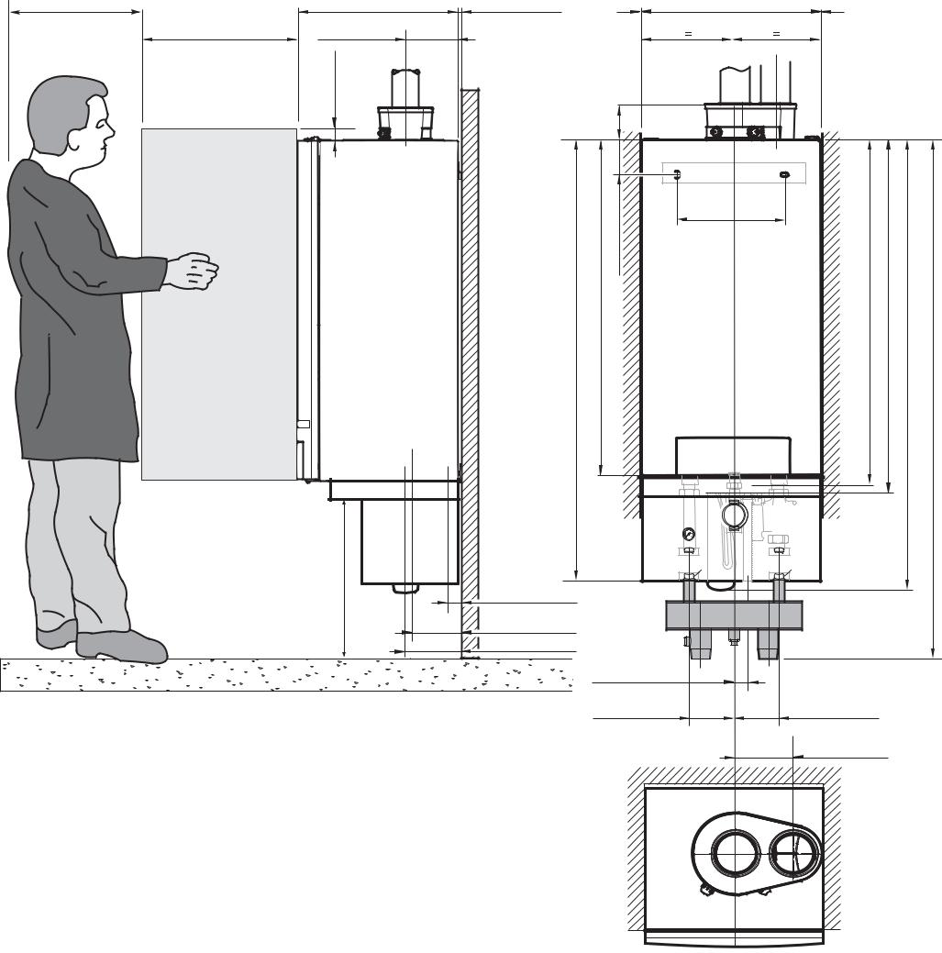

**A** **B**

|  |
| --- |
| 1.2” |

4.1” (103.5 mm)

|  |  |  |
| --- | --- | --- |
|  | mm) | 5.3” (135 mm) |
| (1280 mm) | 38.58” (980 |  |
| 50.4” |  |  |

**C**

16” (406 mm)

|  |  |
| --- | --- |
| 39.5” (1003 mm)40,55”(1030mm)51.6”(1310mm) | 59.68" (1515.87 mm) |

24.8” (630 mm)

1.4” (35 mm)

5.4” (138 mm)

6.4” (162 mm)

**G** **G** 

**D****E**

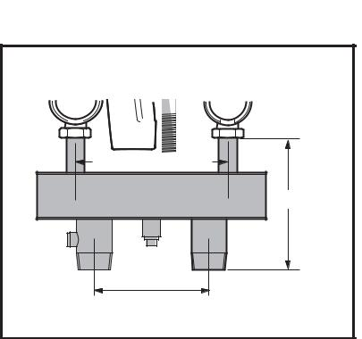

|  |  |  |
| --- | --- | --- |
| 1.54” (39 mm) **J** | **H** |  |
| 5.1” (130 mm) | **F** |  |
|  | 5.1” (130 mm) |  |
|  | **Low Loss Header Exploded View** |  |
|  | 5.5” (140 mm) |  |
|  | 10.2" (260.35 mm) |  |
|  | 9" (228.6 mm) |  |

7.875" (200.02 mm)



**Boiler Dimensions / Connections Data**

|  |  |  |  |  |  |
| --- | --- | --- | --- | --- | --- |
| **Item** | **Description** | **Unit** |  | **Value** |  |
| A | Flue gas connection (inside diameter) | Inch (mm) |  | 4 (100) |  |
| B | Air intake (inside diameter) | Inch (mm) |  | 4 (100) |  |
| C | Wall bracket | − |  | − |  |
| D | Boiler Supply Isolation Valve | Inch (mm) |  | − |  |
| E | Boiler Return Isolation Valve | Inch (mm) |  | − |  |
| F | Siphon (Condensate Trap) | Inch (mm) |  | − |  |
| G | Boiler Gas Shut-off Valve | Inch (mm) |  | 1 (25.4) FPT |  |
| H | Low Loss Header Return Connection | Inch (mm) |  | 2 (51) MPT |  |
| J | Low Loss Header Supply Connection | Inch (mm) |  | 2 (51) MPT |  |
|  |  |  |  | |  |
|  |  | Bosch Thermotechnology Corp. | | |  |
| 4 of 6 |  | Londonderry, NH | | • Ft. Lauderdale, FL |  |
|  |  |  |  |  |

|  |  |  |
| --- | --- | --- |
| Bosch Thermotechnology Corp. reserves the right to make changes without notice due to | Tel: 1-800-283-3787 Fax: 1-603-965-7581 www.buderus.us |  |
| continuing engineering and technological advances | BTC 432008101 D | 12.2013 |  |  |
|  |  |  |

GB162-80



Condensing Gas Boiler

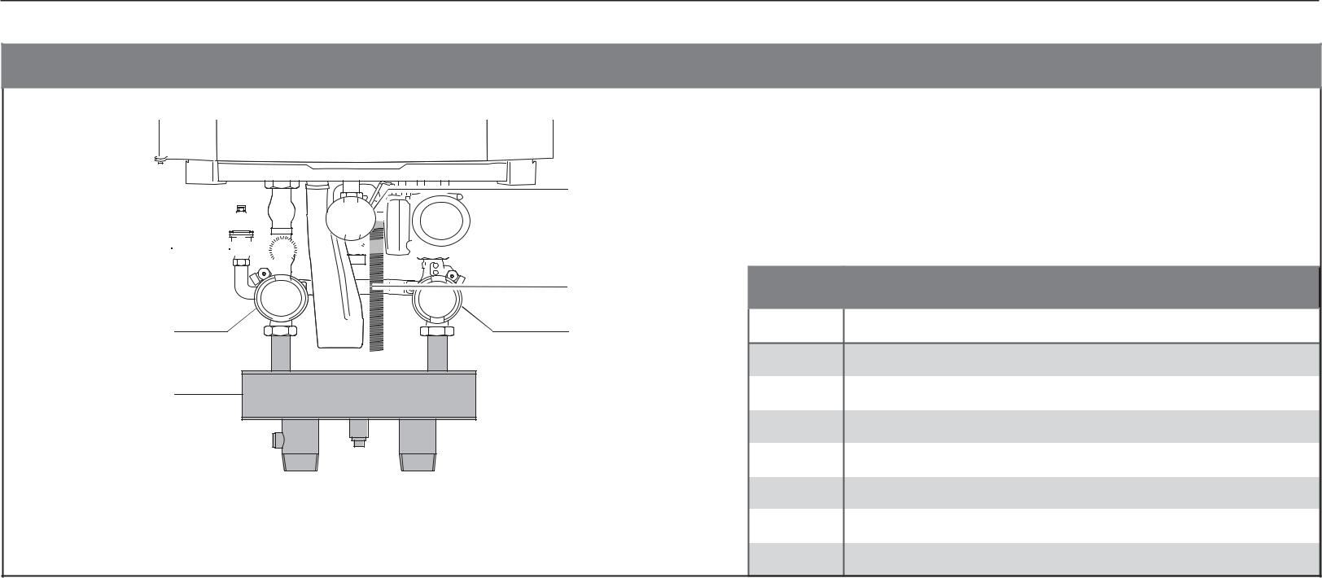

**Pump Group / Low Loss Header Overview**

GB162

3

 4 1 

5

|  |  |  |  |  |
| --- | --- | --- | --- | --- |
| 2 | 6 | **Ref** | **Description** |  |
|  |  | 1 | Pressure relief valve |  |
| 7 |  | 2 | Boiler supply isolation valve |  |
|  |  | 3 | Manual gas shutoff valve |  |
|  |  | 4 | Circulator pump |  |
|  |  | 5 | Siphon (Condensate Trap) |  |
| * Pump group cover not shown |  | 6 | Boiler return isolation valve |  |
| ** Low Loss Header is used on single boiler installations only |  | 7 | Low loss header |  |
|  |  |  |

**Grundfos UP 26-99 F Pressure Drop Curve**

|  |  |  |  |  |  |  |  |  |  |
| --- | --- | --- | --- | --- | --- | --- | --- | --- | --- |
| H |  |  |  |  |  |  |  |  |  |
| [ft] |  |  |  |  |  |  |  |  |  |
| 32 |  |  |  |  |  |  |  |  |  |
| 28 |  |  |  |  |  |  |  |  |  |
| 24 |  |  |  |  |  |  |  |  |  |
| 20 |  |  |  |  |  |  |  |  |  |
| 16 |  |  |  |  |  |  |  |  |  |
| 12 |  |  |  |  |  |  |  |  |  |
| 8 |  |  |  |  |  |  |  |  |  |
| 4 |  |  |  |  |  |  |  |  |  |
| 0 |  |  |  |  |  |  |  |  |  |
| 0 | 4 | 8 | 12 | 16 | 20 | 24 | 28 | 32 | 36 |
|  |  |  |  |  |  |  |  | Q [GPM] |  |

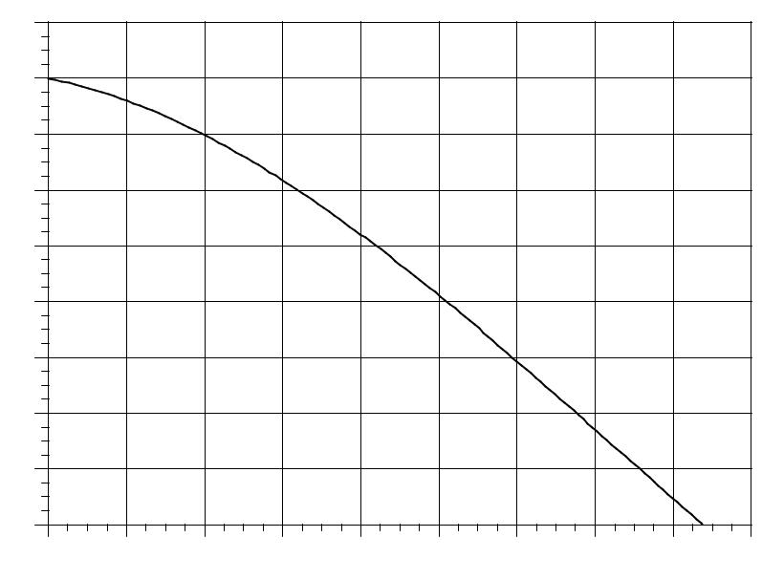

Bosch Thermotechnology Corp.

Londonderry, NH • Ft. Lauderdale, FL

5 of 6

|  |  |  |
| --- | --- | --- |
| Bosch Thermotechnology Corp. reserves the right to make changes without notice due to | Tel: 1-800-283-3787 Fax: 1-603-965-7581 www.buderus.us |  |
| continuing engineering and technological advances | BTC 432008101 D | 12.2013 |  |  |
|  |  |  |

GB162-80



Condensing Gas Boiler

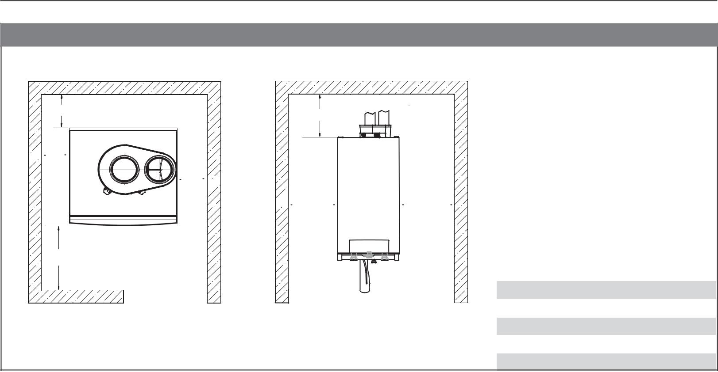

**Boiler Clearances**

W4

W5

 W1

 W2 

 W1 W2 

W3

Top View Front View

|  |  |  |  |
| --- | --- | --- | --- |
|  |  |  |  |
| **Description** | **Unit** | **Minimum** |  |
|  |  | **clearance** |  |
|  |  |  |  |
|  |  |  |  |
| Wall clearance W1 | Inch (mm) | 0 |  |
| Wall clearance W2 | Inch (mm) | 0 |  |
| Wall clearance W3 | Inch (mm) | 37 (940) |  |
| Wall clearance W4 | Inch (mm) | 0 |  |
| Top clearance W5 | Inch (mm) | 6 (152) |  |
|  |  |  |  |

**DISCLAIMER**

Bosch Thermotechnology Corp. makes no warranty or representation, expressed or implied, with respect to the accuracy, completeness, or usefulness of this information, nor assumes any liability with respect to the use of any information contained within this document.

|  |  |  |
| --- | --- | --- |
|  | Bosch Thermotechnology Corp. |  |
| 6 of 6 | Londonderry, NH • Ft. Lauderdale, FL |  |
|  |  |

Bosch Thermotechnology Corp. reserves the right to make changes without notice due to continuing engineering and technological advances | BTC 432008101 D | 12.2013

Tel: 1-800-283-3787 Fax: 1-603-965-7581 www.buderus.us