**GB312-120**

**Condensing Gas Boiler**

Engineering



Submittal



Sheet



**Boiler Overview**

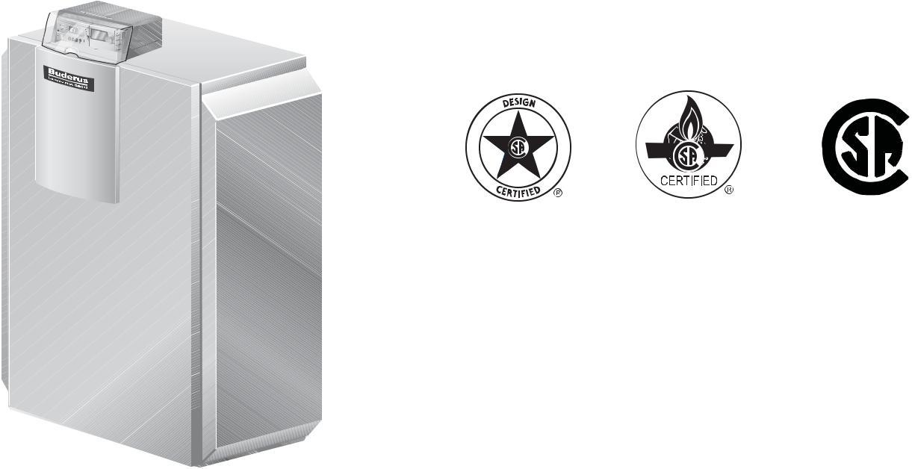

 ®

C US



**Engineering Specifications**

There shall be provided and installed a quantity of _____ Buderus GB312/120 condensing hot water boiler(s), suitable for induced draft

fi ring with natural gas. Boiler(s) shall have a minimum AHRI combustion effi ciency rating of 92% at full load.

Boiler(s) shall utilize a siliconized cast aluminum heat exchanger with high quality condensing heating surfaces.

Boiler(s) shall be constructed, tested and labeled in accordance with ASME Section IV and shall bear the ASME stamp. Boilers shall be CSA approved and have an applicable Canadian Registration number.

Heat exchanger shall be labeled for 50psig maximum working pressure rating. An integrated pressure sensor shall ensure minimum and maximum water pressures are not exceeded.

Boiler shall be capable of modulating fi ring from 25 - 100% of capacity continuously based upon (i) supply and return water temperatures, and/or (ii) outdoor reset computerized control.

Standard equipment shall include a manifold assembly; pressure/ temperature gauge, 50psig relief valve, and fl ow check valve. Leveling feet are included as standard.

Minimal clearances shall be integral to the boiler cabinet design; removable panels shall be used to access heat exchanger, burner components, gas valve and sensors.

Integrated controller shall monitor and control all combustion process functions, control of the boiler water temperature to a value required by the connected components and shall display current water temperatures or fault conditions with changes in operation status. Additional control functions shall include an on/off button, rotary temperature knobs, LED for burner operation and button for fault condition reset.

Independent outdoor temperature reset may be accomplished with the optional AM10 controller; a mounting enclosure shall be included with the provided resistance dependent sensor. Standard communication interface from the AM10 to boiler shall be a two-wire low voltage bus.

|  |  |
| --- | --- |
|  | Bosch Thermotechnology Corporation |
| 1 of 6 | Londonderry, NH • Ft. Lauderdale, FL • Irvine, CA |

|  |  |  |
| --- | --- | --- |
| Bosch Thermotechnology Corp. reserves the right to make changes without notice due to | Tel: 1-800-283-3787 Fax: 1-603-965-7581 www.buderus.us |  |
| continuing engineering and technological advances | BTC 431008102 D | 06.2012 |  |  |
|  |  |  |

GB312-120



Condensing Gas Boiler



**Performance Data**

|  |  |  |
| --- | --- | --- |
|  | **Unit** | **Value** |
|  |  |  |
| Boiler sections | – | 4 |
| Gas input | MBtu/h | 440.5 |
| Gross rated output | MBtu/h | 409 |
| IBR Rating | MBtu/h | 356 |
| Boiler horsepower | H.P | 12.2 |
| AHRI natural gas combustion effi ciency | % | 93.1 |
| AHRI natural gas thermal effi ciency | % | 92.8 |
|  |  |  |

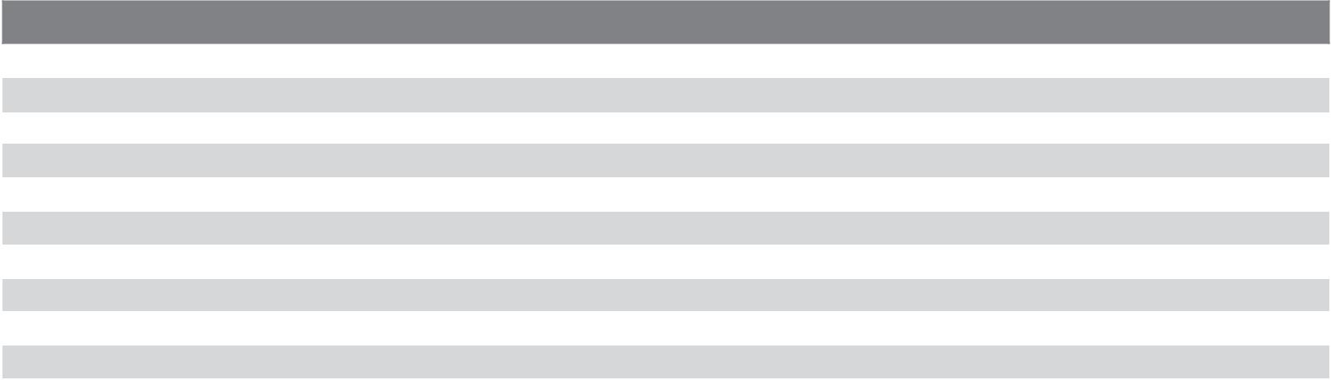

**General Data**

|  |  |  |
| --- | --- | --- |
|  | **Unit** | **Value** |
|  |  |  |
| Boiler category | – | Condensing |
| Heat exchanger construction | – | Aluminum |
| Maximum allowable working pressure | PSIG | 50 |
| Water content | Gallons | 4.2 |
| Weight - shipping (approx.) | Lbs | 455 |
| Weight - operating (approx.) | Lbs | 509 |
| Standard relief valve size (inlet x outlet) | Inch | ¾ x 1 |
| Standard relief valve pressure rating (other capacities available upon request) | PSI | 50 |
| Venting category | – | IV |
|  |  |  |



**Operational Data**

|  |  |  |
| --- | --- | --- |
|  | **Unit** | **Value** |
|  |  |  |
| Fireside pressure drop | Inch W.C. | 0.63 |
| Minimum fl ow rate | GPM | 23.0 |
| Maximum fl ow rate | GPM | 43.0 |
| Maximum supply water temperature | °F | 180 |
| Minimum return water temperature | °F | < 54° Supply |
|  |  |  |

2 of 6

Bosch Thermotechnology Corporation Londonderry, NH • Ft. Lauderdale, FL • Irvine, CA

|  |  |  |
| --- | --- | --- |
| Bosch Thermotechnology Corp. reserves the right to make changes without notice due to | Tel: 1-800-283-3787 Fax: 1-603-965-7581 www.buderus.us |  |
| continuing engineering and technological advances | BTC 431008102 D | 06.2012 |  |  |
|  |  |  |

GB312-120



Condensing Gas Boiler



**Burner Data**

|  |  |  |  |
| --- | --- | --- | --- |
|  | **Unit** | **Value** |  |
|  |  |  |  |
| Allowable fuels | – | Natural gas |  |
| Min Inlet Gas Pressure - NG | Inch W.C. | 3.5 |  |
| Max Inlet Gas Pressure - NG | Inch W.C. | 10.5 |  |
| Motor voltages, gas/oil pressure and modes of operation will vary based upon fi nal burner selection - see | – | – |  |
| burner specifi cation sheet for additional details |  |
|  |  |  |
|  |  |  |  |



**Approval Data**

|  |  |
| --- | --- |
| **Approval description** | **Approval number** |
|  |  |
| Massachusetts Approval # | G1-0409-410 |
| New York MEA # | N/A |
| CRN # | 7834.7C |
|  |  |

**Boiler Pressure Drop Curve**

|  |
| --- |
| **Feet of Head** |

23



22

21

20

19

18

17

16

15

14

13

12

11

10

9

8

7

6

5

4

3

2

1

0

0 10 20 30 40 50 60 70

|  |  |  |
| --- | --- | --- |
|  | **Flowrate (GPM)** |  |
|  |  |  |
|  | Bosch Thermotechnology Corporation |  |
| 3 of 6 | Londonderry, NH • Ft. Lauderdale, FL • Irvine, CA |  |
|  |  |  |
| Bosch Thermotechnology Corp. reserves the right to make changes without notice due to | Tel: 1-800-283-3787 Fax: 1-603-965-7581 www.buderus.us |  |
| continuing engineering and technological advances | BTC 431008102 D | 06.2012 |  |  |
|  |  |  |

GB312-120



Condensing Gas Boiler



**Boiler Dimensions and Connections**



|  |  |  |  |
| --- | --- | --- | --- |
|  | 28³⁄₁₆" | 8½" |  |
| 59¹¹⁄ " |  |  |  |
| 55 ⅛" |  |  |  |
|  |  | 45" |  |
|  |  | 40⅛" |  |
|  |  | 24³⁄₁₆" |  |
|  |  | 8¹¹⁄ " |  |
|  |  | 3¹⁵⁄₁₆" |  |
|  | 19½" |  |  |
| ⅝ - 1" | 1⁵⁄₁₆" |  |  |
|  |  |  |
| 8½" |  |  |  |

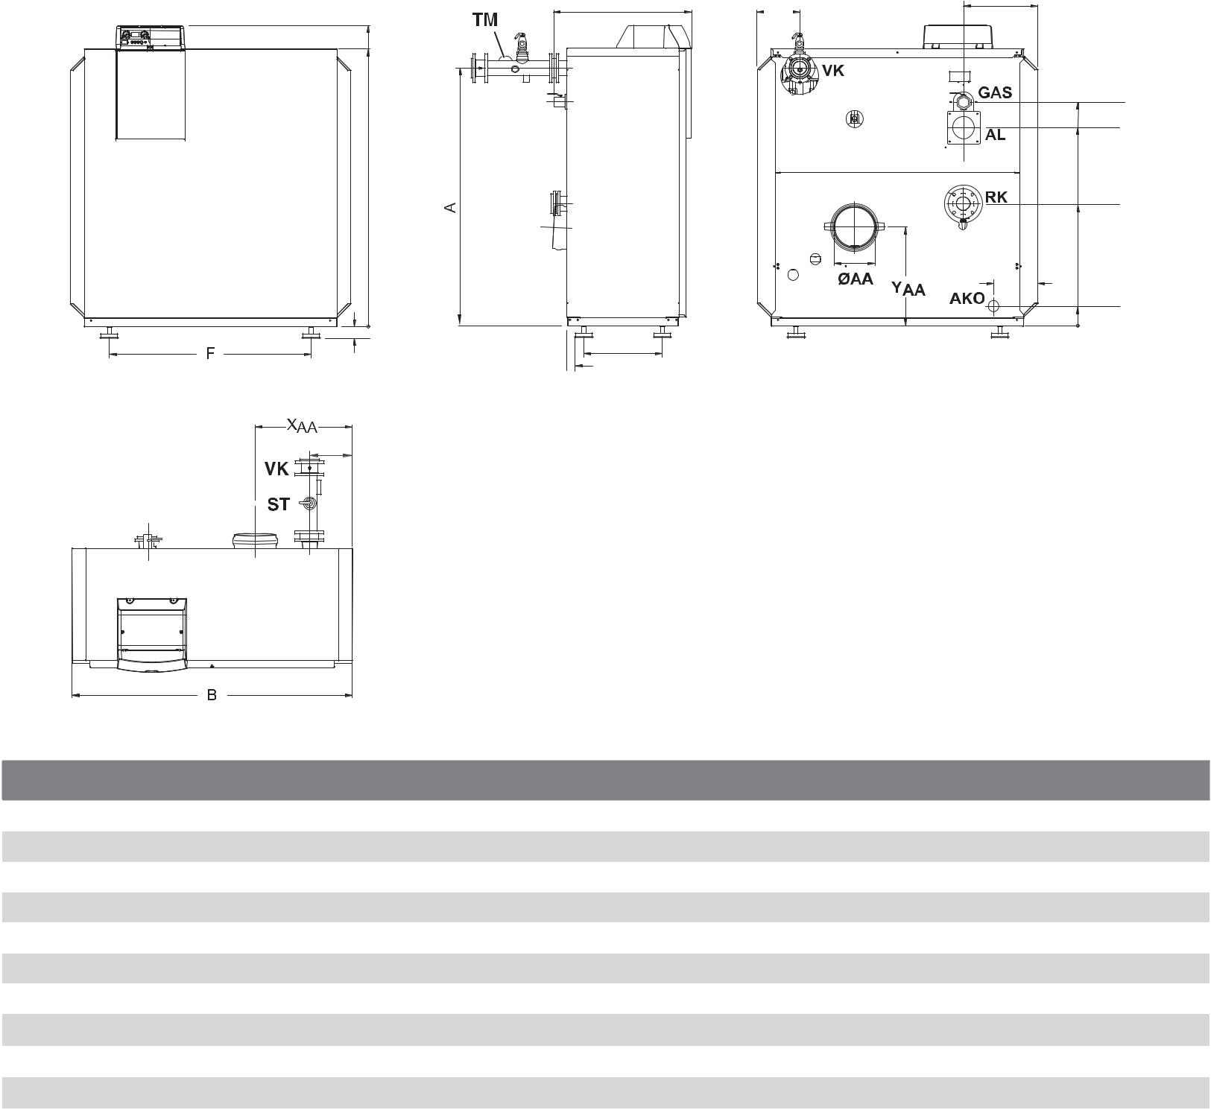

**Boiler Dimensions / Connections Data**

|  |  |  |  |
| --- | --- | --- | --- |
| **Item** | **Description** | **Unit** | **Value** |
|  |  |  |  |
| RK | Boiler return | Inch | 2½ |
| VK | Boiler supply | Inch | 2½ |
| AKO | Boiler condensate outlet | Inch | ¾ |
| ØAA | Flue gas connection (inside diameter) | Inch | 6 |
| AL | Combustion air connection (inside diameter) | Inch | 4 |
| GAS | Gas connection size | Inch | 1 |
|  | Boiler length including outer casing | Inch | 28³⁄₁₆ |
|  | Boiler block height | Inch | 55⅛ |
| B | Min. boiler block width | Inch | 39⅛ |
|  |  |  |  |

* All dimensions above are within +/- ¼".

|  |  |  |
| --- | --- | --- |
|  | Bosch Thermotechnology Corporation |  |
| 4 of 6 | Londonderry, NH • Ft. Lauderdale, FL • Irvine, CA |  |
|  |  |

|  |  |  |
| --- | --- | --- |
| Bosch Thermotechnology Corp. reserves the right to make changes without notice due to | Tel: 1-800-283-3787 Fax: 1-603-965-7581 www.buderus.us |  |
| continuing engineering and technological advances | BTC 431008102 D | 06.2012 |  |  |
|  |  |  |

GB312-120



Condensing Gas Boiler

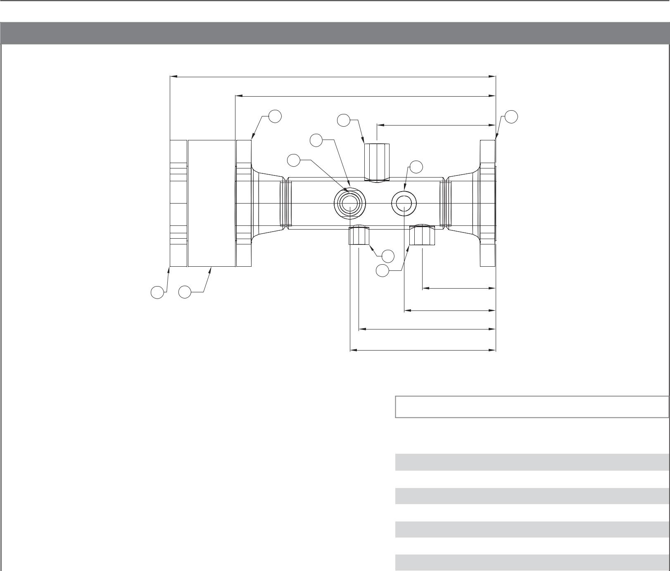

**B-Kit Assembly with Flow Check Valve**

**18"**

|  |  |  |  |  |  |
| --- | --- | --- | --- | --- | --- |
|  |  | **14½"** |  |  |  |
| **1** |  | **4** | **6½"** | **1** |  |
| **Far** |  | **5** |  |  |  |
| **3** |  | **Far** |  |  |
| **Side** |  | **3 Side** |  |  |

|  |  |
| --- | --- |
|  | **2** |
|  | **3** |
|  | **4**⅛**"** |
| **7** | **6** |
|  | **5**⅛**"** |
|  | **7½"** |
|  | **8**⅛**"** |

|  |  |  |  |
| --- | --- | --- | --- |
|  |  |  |  |
|  | **Item** | **Description** | **Qty** |
|  |  |  |  |
|  | 1 | 2½" Flange to boiler | 2 |
|  | 2 | ½" Female NPT | 1 |
|  | 3 | ¾" Female NPT | 3 |
|  | 4 | ¾" Female NPT | 1 |
|  | 5 | 1" Female NPT | 1 |
|  | 6 | 2½" Check Valve | 1 |
|  | 7 | 2½" Female NPT Mating Flange to system | 1 |
|  |  |  |  |

|  |  |  |
| --- | --- | --- |
|  | Bosch Thermotechnology Corporation |  |
| 5 of 6 | Londonderry, NH • Ft. Lauderdale, FL • Irvine, CA |  |
|  |  |

|  |  |  |
| --- | --- | --- |
| Bosch Thermotechnology Corp. reserves the right to make changes without notice due to | Tel: 1-800-283-3787 Fax: 1-603-965-7581 www.buderus.us |  |
| continuing engineering and technological advances | BTC 431008102 D | 06.2012 |  |  |
|  |  |  |

GB312-120



Condensing Gas Boiler

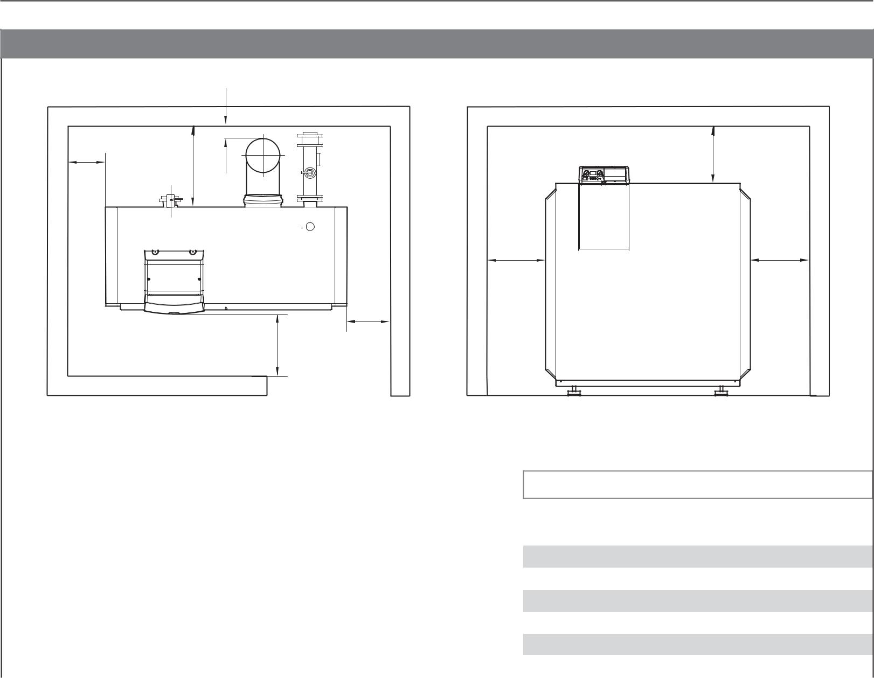

**Boiler Clearances**

|  |  |  |
| --- | --- | --- |
|  | W5 |  |
| W1 | W6 |  |
| W4 |  |
|  |  |

|  |  |
| --- | --- |
| W1 | W2 |

W2

W3

Top View Front View

|  |  |  |  |  |
| --- | --- | --- | --- | --- |
|  |  |  |  |  |
|  | **Description** | **Unit** | **Recommended clearance** |  |
|  | **(minimum clearance)** |  |
|  |  |  |  |
|  |  |  |  |  |
|  | Wall clearance W1 | Inch | 28 (20) |  |
|  | Wall clearance W2 | Inch | 28 (20) |  |
|  | Wall clearance W3 | Inch | 28 (20) |  |
|  | Wall clearance W4 | Inch | 28 (22) |  |
|  | Wall clearance W5 | Inch | 14 (6) |  |
|  | Top clearance W6 | Inch | 24 (12) |  |
|  |  |  |  |  |

**DISCLAIMER**

Bosch Thermotechnology Corp. makes no warranty or representation, expressed or implied, with respect to the accuracy, completeness, or usefulness of this information, nor assumes any liability with respect to the use of any information contained within this document.

|  |  |  |
| --- | --- | --- |
|  | Bosch Thermotechnology Corporation |  |
| 6 of 6 | Londonderry, NH • Ft. Lauderdale, FL • Irvine, CA |  |
|  |  |

|  |  |  |
| --- | --- | --- |
| Bosch Thermotechnology Corp. reserves the right to make changes without notice due to | Tel: 1-800-283-3787 Fax: 1-603-965-7581 www.buderus.us |  |
| continuing engineering and technological advances | BTC 431008102 D | 06.2012 |  |
|  |  |