**SB615/400 Stainless Steel**

**Condensing Boiler**

Engineering



Submittal



Sheet



**Boiler Components**

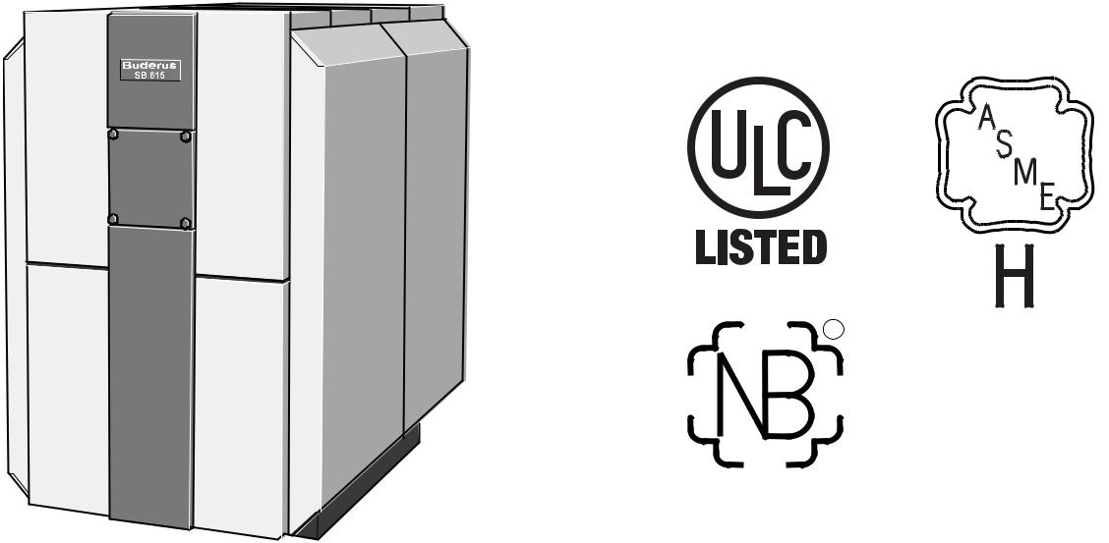

R



**Engineering Specifications**

The boiler(s) shall have a full three pass fire tube design to allow complete combustion of the fuel in the main combustion cham-ber. All flue side surfaces, including the main combustion cham-ber, second and third flue passages shall be constructed of 316 stainless steel designed to maximize the condensate formation. All flue passages shall be fully water-backed to minimize thermal stresses on the boiler vessel.

Boiler(s) shall be constructed with dual return water connections where the lower connection shall be aligned with the lowest (coldest) return water temperature for maximum efficiency.

Boiler(s) shall be suitable to operate under any return water tem-perature, any boiler water flow rate and without any restrictions on temperature rise through the boiler vessel. Boiler(s) shall be able to operate at efficiencies up to 98% at suitably low return water temperatures.

The condensing secondary and tertiary fire tube flue passages shall be fabricated from 316 stainless steel with a reduced cross section in the direction of flue products flow to maintain a near constant velocity of combustion products and to enhance micro turbulences for maximum heat transfer.

Boiler(s) shall have an internal water baffle plate separating return water between second and third flue passages for maximum efficiency.

Boiler(s) shall be fully serviceable from the front by means of a reversible swing burner door and removable access cover.

The boiler vessel shall be wrapped with a full 4" thermal insulation blanket for minimal stand-by loss.

|  |  |
| --- | --- |
|  | Bosch Thermotechnology Corp. |
| 1 of 5 | Londonderry, NH • Ft. Lauderdale, FL |

|  |  |  |
| --- | --- | --- |
| Bosch Thermotechnology Corp. reserves the right to make changes without notice due | Tel: 1-800-283-3787 Fax: 1-603-965-7581 www.buderus.us |  |
| to continuing engineering and technological advances | BTC 433008105 B | 03.2013 |  |  |

SB615/400



Stainless Steel Condensing Boiler



**Performance Data**

|  |  |  |
| --- | --- | --- |
|  | **Unit** | **Value** |
|  |  |  |
| Gas input | MBtu/h | 1393 |
| Gross rated output | MBtu/h | 1317 |
| IBR Rating | MBtu/h | 1145 |
| Boiler horsepower | H.P | 39.3 |
| AHRI natural gas combustion efficiency | % | 96.3 |
| AHRI natural gas thermal efficiency | % | 94.5 |
| AHRI Ultra-Low Sulfur Diesel combustion efficiency | % | 95.1 |
| AHRI Ultra-Low Sulfur Diesel thermal efficiency | % | 92.4 |
|  |  |  |

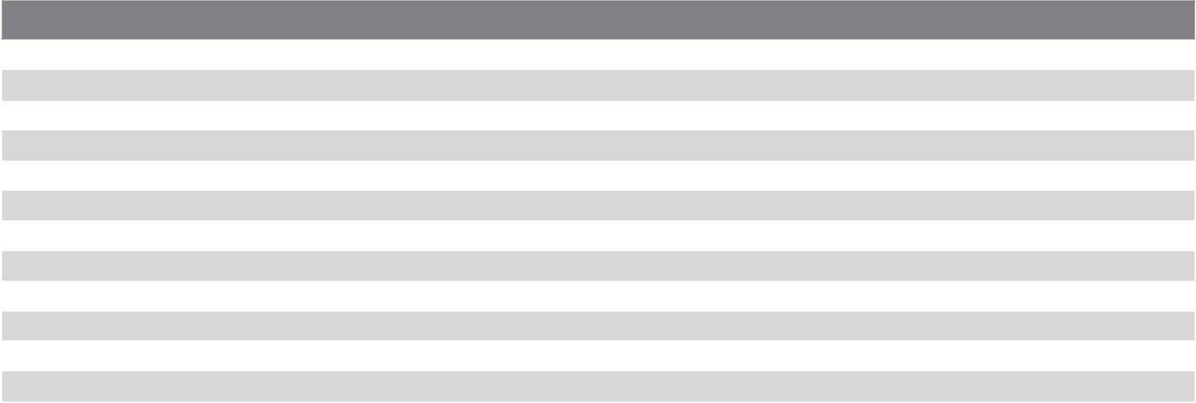

**General Data**

|  |  |  |
| --- | --- | --- |
|  | **Unit** | **Value** |
|  |  |  |
| Boiler category | – | Condensing |
| Heat exchanger construction | – | Stainless steel |
| Heating surface | Sq. Ft | 192.67 |
| Maximum allowable working pressure | PSIG | 30 |
| Water content | Gallons | 180 |
| Weight - shipping (approx.) | Lbs | 2600 |
| Weight - operating (approx.) | Lbs | 4119 |
| Standard relief valve size (inlet x outlet) | Inch | 1¼ x 1½ |
| Standard relief valve pressure rating (other capacities available upon request) | PSI | 30 |
| Minimum relief valve capacity | MBH | 1541.4 |
| Venting category | – | IV |
|  |  |  |



**Operational Data**

|  |  |  |
| --- | --- | --- |
|  | **Unit** | **Value** |
|  |  |  |
| Fireside pressure drop | Inch W.C. | 1.22 |
| Required vent connection pressure | Inch W.C. | +.01 − +0.2 |
| Maximum allowable firebox pressure | Inch W.C. | 0.20 |
| Minimum flow rate | GPM | none |
| Maximum flow rate | GPM | none |
| Maximum supply water temperature | °F | 210 |
| Minimum return water temperature | °F | none |
|  |  |  |

|  |  |  |
| --- | --- | --- |
|  | Bosch Thermotechnology Corp. |  |
| 2 of 5 | Londonderry, NH • Ft. Lauderdale, FL |  |
|  |  |

|  |  |  |
| --- | --- | --- |
| Bosch Thermotechnology Corp. reserves the right to make changes without notice due | Tel: 1-800-283-3787 Fax: 1-603-965-7581 www.buderus.us |  |
| to continuing engineering and technological advances | BTC 433008105 B | 03.2013 |  |  |

SB615/400



Stainless Steel Condensing Boiler



**Burner Data**

|  |  |  |  |
| --- | --- | --- | --- |
|  | **Unit** | **Value** |  |
|  |  |  |  |
| Allowable fuels | – | Natural gas, LP, |  |
| Ultra low sulfur diesel (ASTM D396 No. 2) |  |
|  |  |  |
| Motor voltages, gas/oil pressure and modes of operation will vary based upon final burner | – | – |  |
| selection - see burner specification sheet for additional details |  |
|  |  |  |
|  |  |  |  |



**Approval Data**

|  |  |
| --- | --- |
| **Approval description** | **Approval number** |
|  |  |
| Massachusetts Approval # | G3-0610-0523 |
| New York MEA # | MEA 444-04-E |
| CRN # | K8251.1C |
|  |  |

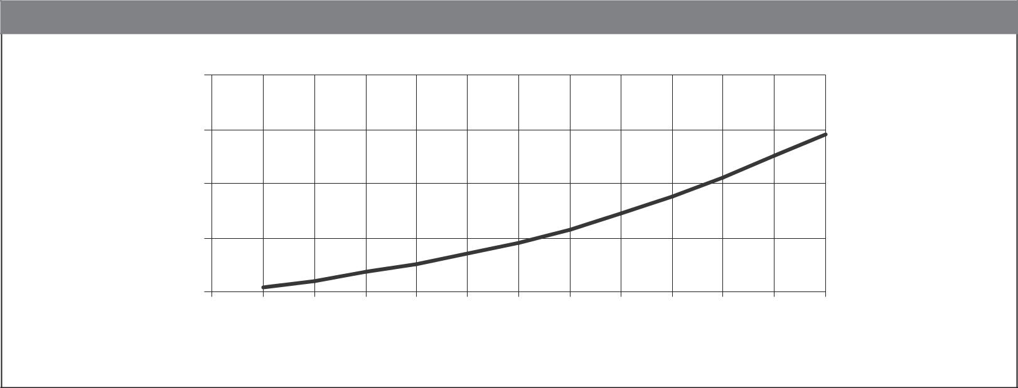

**Boiler Pressure Drop Curve**

|  |  |  |  |  |  |  |  |  |  |  |  |  |  |  |
| --- | --- | --- | --- | --- | --- | --- | --- | --- | --- | --- | --- | --- | --- | --- |
|  | 4 |  |  |  |  |  |  |  |  |  |  |  |  |  |
| **of Head** | 3 |  |  |  |  |  |  |  |  |  |  |  |  |  |
| 2 |  |  |  |  |  |  |  |  |  |  |  |  |  |
| **Feet** | 1 |  |  |  |  |  |  |  |  |  |  |  |  |  |
|  | 0 |  |  |  |  |  |  |  |  |  |  |  |  |  |
|  | 25 | 50 | 75 | 100 | 125 | 150 | 175 | 200 | 225 | 250 | 275 | 300 | 325 |  |

**Flowrate (GPM)**

|  |  |
| --- | --- |
|  | Bosch Thermotechnology Corp. |
| 3 of 5 | Londonderry, NH • Ft. Lauderdale, FL |

|  |  |  |
| --- | --- | --- |
| Bosch Thermotechnology Corp. reserves the right to make changes without notice due | Tel: 1-800-283-3787 Fax: 1-603-965-7581 www.buderus.us |  |
| to continuing engineering and technological advances | BTC 433008105 B | 03.2013 |  |  |

SB615/400



Stainless Steel Condensing Boiler



**Boiler Dimensions and Connections**

|  |  |  |  |
| --- | --- | --- | --- |
|  |  | L |  |
|  |  | LK |  |
|  |  | M |  |
|  |  | VK |  |
| 1 | H | AA |  |
| H |  |
|  |  | Ø |  |
|  |  | RK2 |  |
|  |  | RK1 |  |
|  | AA | AKO |  |
|  | H |  |
|  | B | EK/EL |  |
|  |  |  |

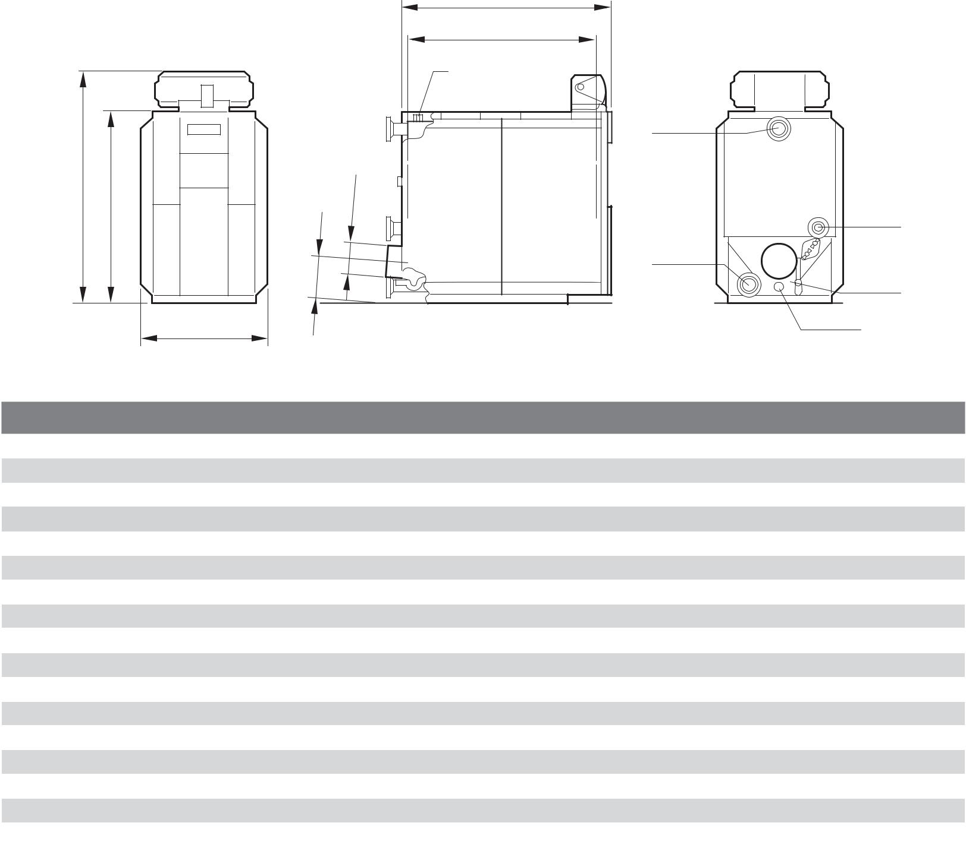

**Boiler Dimensions / Connections Data**

|  |  |  |  |
| --- | --- | --- | --- |
| **Item** | **Description** | **Unit** | **Value** |
|  |  |  |  |
| ØAA | Boiler flue inner diameter | Inch (mm) | 10 (253) |
| HAA | Boiler flue height | Inch | 13 |
| AKO | Condensate outlet | Inch | ½ |
| EK/EL | Cold water inlet/drain | Inch | 1 ½ |
| H | Boiler height | Inch | 63 ½ |
| H₁ | Boiler height including controller Logamatic 4321/22 controller = H + 10” (235mm) | Inch | 73 ½ |
| RK1 | Boiler return (low temperature) | Inch | 4 |
| HRK1 | Boiler return height (from boiler base to centerline) | Inch | 5¹⁵⁄₁₆ |
| RK2 | Boiler return (medium temperature) | Inch | 2 ½ |
| HRK2 | Boiler return height (from boiler base to centerline) | Inch | 23 ½ |
| VK | Boiler supply | Inch | 4 |
| HVK | Boiler supply height (from boiler base to centerline) | Inch | 56 ¾ |
| M | Sensing point for temperature sensor/immersion sleeve | – | – |
| L | Boiler length including outer casing | Inch | 70 |
| LK | Boiler heat exchanger length | Inch | 61 |
| B | Boiler width including outer casing | Inch | 38 ½ |
|  |  |  |  |

* All dimensions above are within +/- ¼".

|  |  |  |
| --- | --- | --- |
|  | Bosch Thermotechnology Corp. |  |
| 4 of 5 | Londonderry, NH • Ft. Lauderdale, FL |  |
|  |  |

|  |  |  |
| --- | --- | --- |
| Bosch Thermotechnology Corp. reserves the right to make changes without notice due | Tel: 1-800-283-3787 Fax: 1-603-965-7581 www.buderus.us |  |
| to continuing engineering and technological advances | BTC 433008105 B | 03.2013 |  |  |

SB615/400



Stainless Steel Condensing Boiler



**Supply Manifold Connections**

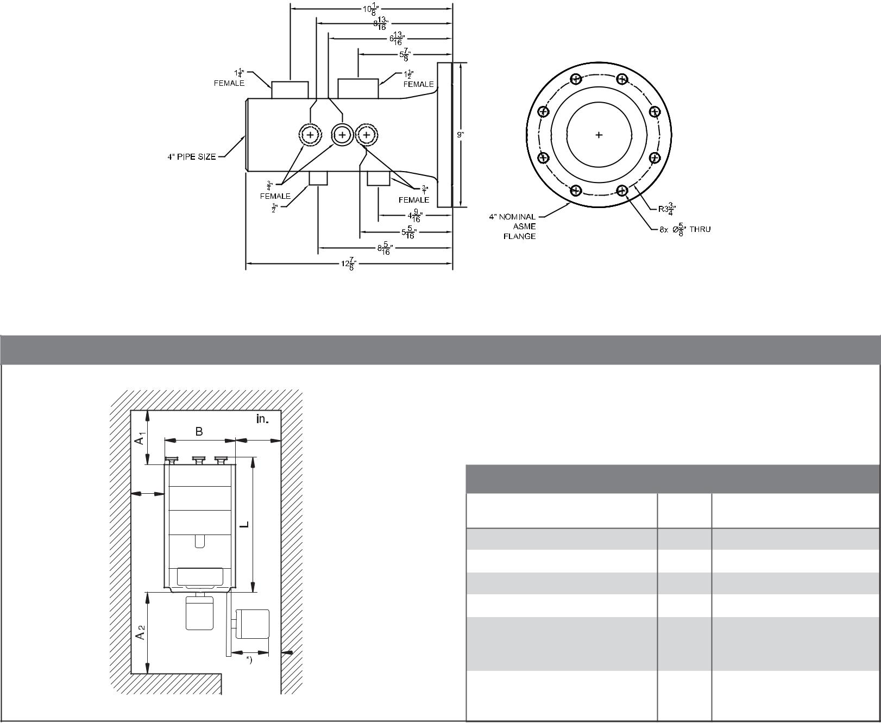

**Recommended (Minimum) Boiler Clearances**

|  |  |  |  |
| --- | --- | --- | --- |
| 32" * |  |  |  |
| min. 4” |  |  |  |
| **Description** | **Unit** | **Recommended clearance** |  |
| **(minimum clearance)** |  |
|  |  |  |
| Length A₁ | Inch | 36 (24) |  |
| Length A₂ | Inch | 72 (54) |  |
| Length L | Inch | 73 |  |
| Width B | Inch | 38 |  |

|  |  |  |  |  |  |
| --- | --- | --- | --- | --- | --- |
| min. 8” | | Minimum Width for the boiler | Inch | 34 (32) |  |
| room opening / door |  |
|  |  |  |  |  |
|  |  | Minimum Height for the boiler | Inch | 64 (62) |  |
|  |  | room opening / door |  |
|  |  |  |  |  |

*) Take burner size into account. Removal of burner may be required if using minimum distance.

**DISCLAIMER**

Bosch Thermotechnology Corp. makes no warranty or representation, expressed or implied, with respect to the accuracy, completeness, or usefulness of this information, nor assumes any liability with respect to the use of any information contained within this document.

|  |  |  |
| --- | --- | --- |
|  | Bosch Thermotechnology Corp. |  |
| 5 of 5 | Londonderry, NH • Ft. Lauderdale, FL |  |
|  |  |

|  |  |  |
| --- | --- | --- |
| Bosch Thermotechnology Corp. reserves the right to make changes without notice due | Tel: 1-800-283-3787 Fax: 1-603-965-7581 www.buderus.us |  |
| to continuing engineering and technological advances | BTC 433008105 B | 03.2013 |  |