**Buderus SB625WS/370**

**Stainless Steel**

**Condensing Boiler**

Engineering



Submittal

Sheet

**Boiler Components**

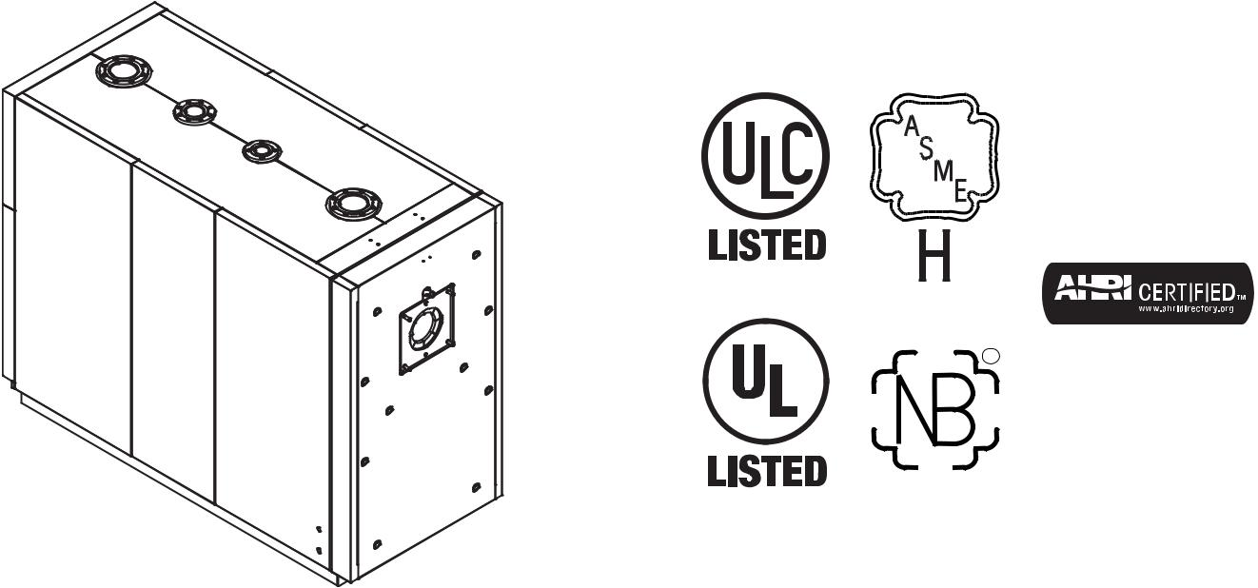

R

®

**Engineering Specifications**

The boiler(s) shall have a full three pass fire tube design to allow complete combustion of the fuel in the main combustion chamber. All flue side surfaces, including the main combustion chamber, second and third flue passages shall be constructed of 316Ti stainless steel designed to maximize condensate formation. All flue passages shall be fully water-backed to minimize thermal stresses on the boiler vessel.

Boiler(s) shall be constructed with dual return water connections where the lower connection shall be aligned with the lowest (coldest) return water temperature for maximum efficiency.

Boiler(s) shall be suitable to operate under any return water temperature, boiler water flow rate and without any restrictions on temperature rise through the boiler vessel. Boiler(s) shall be

able to operate at efficiencies up to 98% at suitably low return water temperatures.

The tertiary fire tube flue passages shall be fabricated from 316Ti stainless steel with turbulators to maintain a near constant velocity of combustion products and to enhance turbulence at the boundary layer for maximum heat transfer.

Boiler(s) shall have an internal water baffle plate separating return water between second and third flue passages for maximum efficiency.

Boiler(s) shall be fully serviceable from the front by means of a reversible swing burner door.

|  |  |
| --- | --- |
|  | Bosch Thermotechnology Corporation |
| 1 of 5 | Londonderry, NH • Ft. Lauderdale, FL |

|  |  |  |
| --- | --- | --- |
| Bosch Thermotechnology Corp. reserves the right to make changes without notice due | Tel: 1-800-283-3787 Fax: 1-603-965-7581 www.bosch-climate.us |  |
| to continuing engineering and technological advances | BTC 437008104 D | 08.2013 |  |  |
|  |  |  |

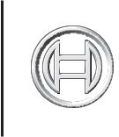Buderus SB625WS/370



Stainless Steel Condensing Boiler

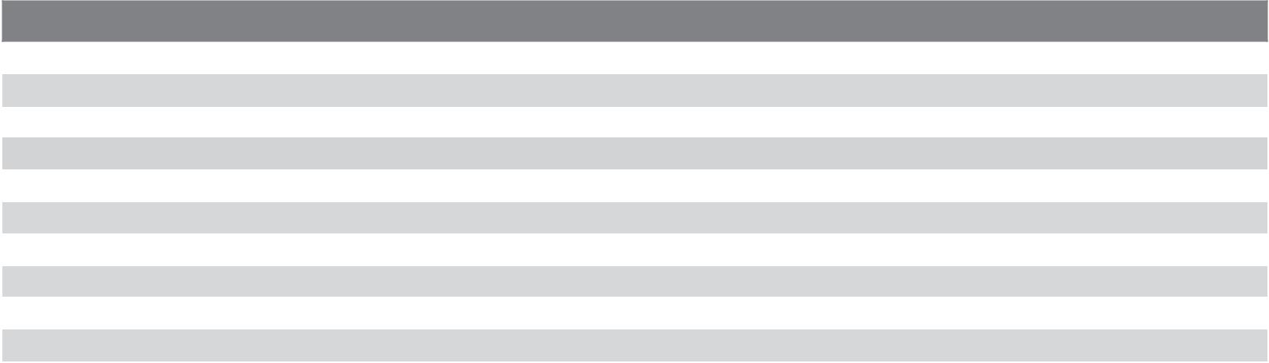

**Performance Data**

|  |  |  |
| --- | --- | --- |
|  | **Unit** | **Value** |
|  |  |  |
| Gas input | MBtu/h [kW] | 1,314 [385.0] |
| Oil input | GPH | 9.4 |
| Gross rated output | MBtu/h [kW] | 1,243 [364.2] |
| Gross output @ 104 °F supply / 86 °F return (40 °C / 30 °C) | MBtu/h [kW] | 1,280 [375.2] |
| Gross output @ 176 °F supply / 140 °F return (80 °C / 60 °C) | MBtu/h [kW] | 1,183 [346.7] |
| IBR Net Rating | MBtu/h [kW] | 1,081 [316.8] |
| Boiler horsepower | H.P | 38.2 |
| AHRI Natural gas combustion efficiency | % | 95.0 |
| AHRI Natural gas thermal efficiency | % | 94.6 |
|  |  |  |



**General Data**

|  |  |  |
| --- | --- | --- |
|  | **Unit** | **Value** |
|  |  |  |
| Boiler category | – | Condensing |
| Heat exchanger construction | – | Stainless steel |
| Heating surface | Sq. Ft [m2] | 175.45 [16.3] |
| Maximum allowable working pressure | PSIG [bar] | 80 [5.5] |
| Water content | Gallons [Liters] | 146.6 [555] |
| Weight - dry | Lbs [kg] | 1,811 [821] |
| Weight - shipping (approx.) | Lbs [kg] | 1,950 [885] |
| Venting category | – | II, IV |
|  |  |  |

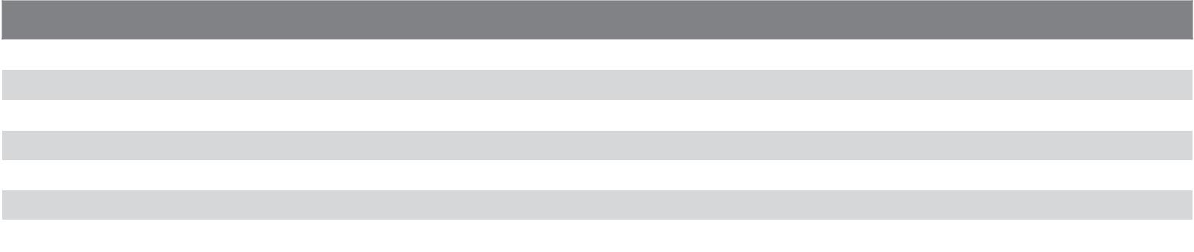

**Operational Data**

|  |  |  |
| --- | --- | --- |
|  | **Unit** | **Value** |
|  |  |  |
| Fireside pressure drop | Inch W.C. [mbar] | 1.846 [4.6] |
| Required vent connection pressure | Inch W.C. [mbar] | +.01 − +0.2 [.025 - .498] |
| Minimum flow rate | GPM [LPM] | none |
| Maximum flow rate | GPM [LPM] | none |
| Maximum supply water temperature | °F [°C] | 210 [98.8] |
| Minimum return water temperature | °F [°C] | none |
|  |  |  |



**Burner Data**

|  |  |  |  |
| --- | --- | --- | --- |
|  | **Unit** | **Value** |  |
|  |  |  |  |
| Allowable fuels | – | Natural gas, LP, Ultra low sulfur diesel (ASTM D396 |  |
| No. 2), Fuel oil no. 2 (with operating requirements) |  |
|  |  |  |
| Motor voltages, gas/oil pressure and modes of operation will vary based upon final burner | – | – |  |
| selection - see burner specification sheet for additional details |  |
|  |  |  |
|  |  |  |  |

|  |  |  |  |
| --- | --- | --- | --- |
|  | Bosch Thermotechnology Corporation | |  |
| 2 of 5 | Londonderry, NH • Ft. Lauderdale, FL | |  |
|  |  |  |  |
|  |  |  |  |
| Bosch Thermotechnology Corp. reserves the right to make changes without notice due | Tel: 1-800-283-3787 Fax: 1-603-965-7581 www.bosch-climate.us | |  |
| to continuing engineering and technological advances | BTC 437008104 D | 08.2013 |  | |  |
|  |  |  |  |

Buderus SB625WS/370



Stainless Steel Condensing Boiler



**Approval Data**

|  |  |
| --- | --- |
| **Approval description** | **Approval number** |
|  |  |
| Massachusetts Plumbing Board | Approved |
| CRN # | W0848.2C |
|  |  |

**Boiler Dimensions (Jacket Installed)**

L

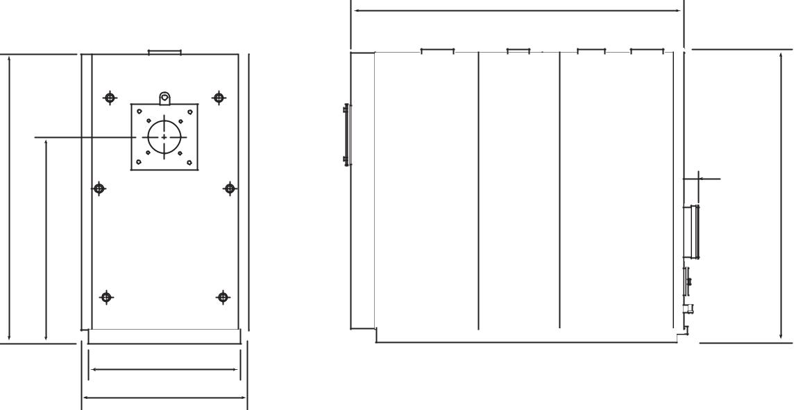

|  |  |
| --- | --- |
|  | D |
| H1 | H |
|  | C |



A

L1

B

|  |  |
| --- | --- |
| FRONT VIEW | RIGHT SIDE VIEW |
| NTS | NTS |



**Boiler Dimensions Data**

|  |  |  |  |  |
| --- | --- | --- | --- | --- |
| **Item** | **Description** | **Unit** |  | **Value** |
| A | Base width | Inch [mm] | 25 | ½ [750] |
| B | Overall width | Inch [mm] | 33 | ½ [850] |
| C | Height of burner plate (centerline) | Inch [mm] | 40 ⁹/₁₆ [1030] | |
| D | Flue depth | Inch [mm] | 2 | ¾ [70] |
| H | Height of water fittings | Inch [mm] | 57 ⅛ [1450] | |
| H1 | Boiler height | Inch [mm] | 56 ½ [1435] | |
| L | Length | Inch [mm] | 72 ¹/₁₆ [1830] | |
| L1 | Base Length | Inch [mm] | 65 ¾ [1670] | |
|  |  |  |  |  |

* All dimensions above are within +/- ¼".

|  |  |  |  |  |
| --- | --- | --- | --- | --- |
|  |  | Bosch Thermotechnology Corporation | |  |
| 3 of 5 |  | Londonderry, NH • Ft. Lauderdale, FL | |  |
|  |  |  |  |  |
| Bosch Thermotechnology Corp. reserves the right to make changes without notice due | Tel: 1-800-283-3787 | Fax: 1-603-965-7581 www.bosch-climate.us | |  |
| to continuing engineering and technological advances | BTC 437008104 D | 08.2013 |  |  | |  |
|  |  |  |  |  |

Buderus SB625WS/370



Stainless Steel Condensing Boiler

**Boiler Block Dimensions and Connections (Jacket Removed)**

|  |  |  |  |  |
| --- | --- | --- | --- | --- |
|  | A | B |  | C |
| N | D | E | F |  |
|  | 1 | 2 | 3 | 4 |
|  |  | 9 |  |  |

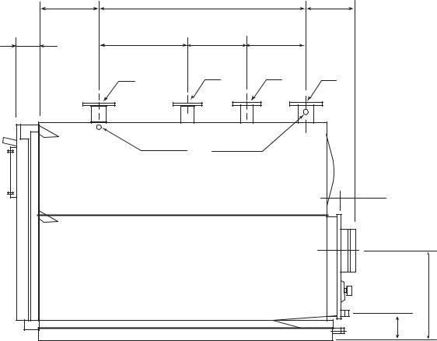

J

|  |
| --- |
| K |

|  |
| --- |
| G |

RIGHT SIDE VIEW

NTS



**Boiler Block Dimensions and Connections Data**

M M

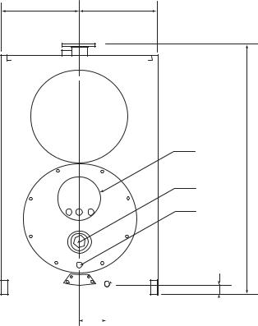

8

|  |
| --- |
| H |

7

6

5

|  |  |  |  |  |  |  |
| --- | --- | --- | --- | --- | --- | --- |
|  |  |  |  |  |  |  |
|  | P |  |  |  | L |  |
|  |  |  |  |

REAR VIEW

NTS

|  |  |  |  |
| --- | --- | --- | --- |
| **Item** | **Description** | **Unit** | **Value** |
|  |  |  |  |
| A | Distance from burner head to heating supply outlet | Inch [mm] | 12 ⅝ [321] |
| B | Distance between heating supply outlet and return 1 | Inch [mm] | 48 ⅝ [1235] |
| C | Distance between heating return 1 and flue gas outlet | Inch [mm] | 10 ⅝ [270] |
| D | Distance between heating supply outlet and safety device fitting | Inch [mm] | 21 ¹/₁₆ [535] |
| E | Distance between heating return 2 and safety device fitting | Inch [mm] | 17 ¾ [450] |
| F | Distance between heating return 1 and 2 | Inch [mm] | 9 ⅞ [250] |
| G | Height of condensate drain | Inch [mm] | 6 ½ [165] |
| H | Height of water fittings | Inch [mm] | 57 ¹/₁₆ [1450] |
| J | Flue depth | Inch [mm] | 2 ¾ [70] |
| K | Height of flue gas outlet (centerline) | Inch [mm] | 21 ½ [545] |
| L | Height of boiler drain fitting | Inch [mm] | 2 ⁷/₁₆ [61] |
| M | Boiler centerline | Inch [mm] | 14 ¾ [375] |
| N | Distance from burner head to door | Inch [mm] | 4 ¾ [120] |
| P | Distance from Boiler drain fitting | Inch [mm] | 5 ⅜ [137] |
| 1 | Heating supply | Inch [DN] | 3 [80] |
| 2 | Safety device fitting | Inch [DN] | 1 ¼ [1.25] |
| 3 | Heating return 2 (High Temperature) | Inch [DN] | 2 ½ [65] |
| 4 | Heating return 1 (Low Temperature) | Inch [DN] | 3 [80] |
| 5 | Boiler drain fitting | Inch | 1 |
| 6 | Condensate drain fitting | Inch | 1 |
| 7 | Inspection port | ― | ― |
| 8 | Flue gas outlet | Ø mm | 250 |
| 9 | Instrument bulb/probe sockets | Inch | 3 x ½ |
|  |  |  |  |

|  |  |  |  |  |  |
| --- | --- | --- | --- | --- | --- |
| * All dimensions above are within +/- ¼". | |  | Bosch Thermotechnology Corporation | |  |
|  | 4 of 5 |  | Londonderry, NH • Ft. Lauderdale, FL | |  |
|  |  |  |  |  |  |
|  | Bosch Thermotechnology Corp. reserves the right to make changes without notice due | Tel: 1-800-283-3787 | Fax: 1-603-965-7581 www.bosch-climate.us | |  |
|  | to continuing engineering and technological advances | BTC 437008104 D | 08.2013 |  |  | |  |
|  |  |  |  |  |  |

Buderus SB625WS/370



Stainless Steel Condensing Boiler



**Boiler Pressure Drop Chart**

|  |  |  |  |
| --- | --- | --- | --- |
| **Temperature Rise** | | **Unit** | **Value** |
|  |  |  |  |
| 20 degree | T | Ft. Hd. [mbar] | 4.5 [134.5] |
| 30 degree | T | Ft. Hd. [mbar] | 3.5 [104.6] |
| 40 degree | T | Ft. Hd. [mbar] | 2.3 [68.7] |
| 100 degree | T | Ft. Hd. [mbar] | 1.0 [30] |
|  |  |  |  |

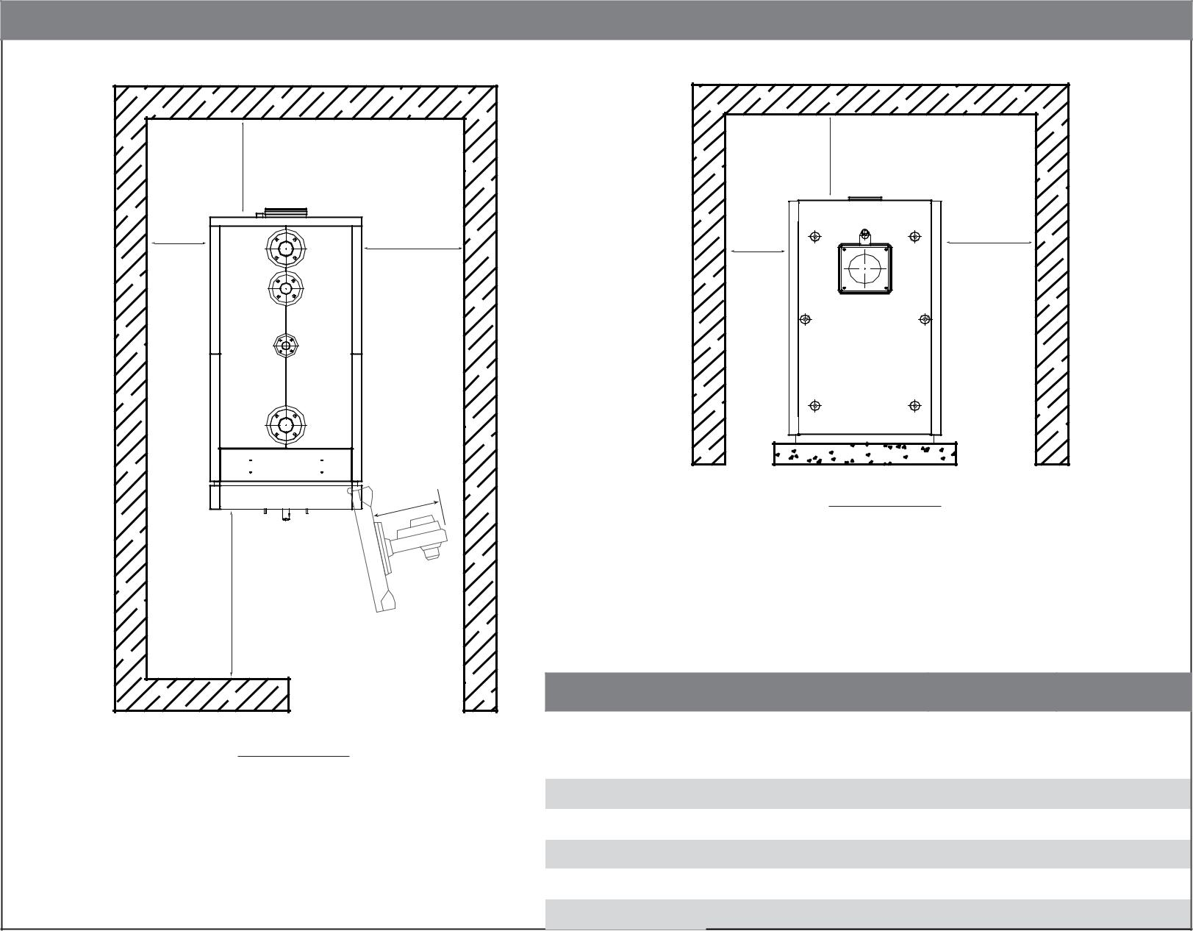

**Boiler Clearances**

|  |  |  |
| --- | --- | --- |
|  | A1 |  |
| B1 | B2 |  |
|  |  |
|  | A2 |  |

TOP VIEW

NTS

* NOTE: An installation using the minimum clearance to combustibles will require modifications to the typical installation process. Boiler must be installed on non-combustible floor. Consult factory for additional details.

|  |  |  |
| --- | --- | --- |
|  | D |  |
| B1 | B2 |  |
|  |  |

FRONT VIEW

NTS

|  |  |  |  |  |  |
| --- | --- | --- | --- | --- | --- |
|  |  | **Recommended** | **Minimum** | **Minimum To** | |
| **Description** | **Unit** | **Service** | **Service** | **Combustible** | |
|  |  | **Clearance** | **Clearance** | **Surface\*** | |
| Length A1 | Inch [mm] | 36 [915] | 24 [610] | 18 [457] | |
| Length A2 | Inch [mm] | 73 [1830] | 64 [1626] | 64 | [1626] |
| Length B1 | Inch [mm] | 36 [915] | 18 [457] | 6 | [152] |
| Length B2 | Inch [mm] | 36 [915] | C + 4 [C + 100] | 6 | [152] |
| Length D | Inch [mm] | 36 [915] | 18 [457] | 18 [457] | |

**DISCLAIMER**

**Specifications subject to change without notice. All dimensions shown on these engineering submittal sheets are for reference only and should not be used for field installation purposes. Please refer to current product installation manuals for detailed installation instructions and dimensions.**

|  |  |  |  |
| --- | --- | --- | --- |
|  | Bosch Thermotechnology Corporation | |  |
| 5 of 5 | Londonderry, NH • Ft. Lauderdale, FL | |  |
|  |  |  |
|  |  |  |  |
| Bosch Thermotechnology Corp. reserves the right to make changes without notice due | Tel: 1-800-283-3787 Fax: 1-603-965-7581 www.bosch-climate.us | |  |
| to continuing engineering and technological advances | BTC 437008104 D | 08.2013 |  |
|  |  |  |